IT 360 Cloud Integration | Week 1 | Lab 2
Cross-Cloud Automation with Ansible
Click-by-click console steps with screenshots, the matching terminal commands, and the verification commands for one Ansible controller on DigitalOcean (or on AWS EC2 when you cannot open a DigitalOcean account) that installs NGINX on a Google Cloud client and an Azure client
Course: IT 360-01 Cloud Integration, Ensign College
Instructor: Jackson Isiko, Ph.D.
Canvas: 1.6 Team Lab 2, Cross-Cloud Automation with Ansible. Time: 90 to 120 minutes.
Companion documents: the Lab 2 README in multi-cloud-ansible-deployment/ (full guide with the Vocareum Azure Sandbox path, troubleshooting and the one-command scripts) and the follow-along video in videos/.
Version: 2026-10-30 (adds the DigitalOcean sign-up links and Step 1A, the controller on AWS EC2 for students who cannot open a DigitalOcean account); verified against a live run on 2026-10-31. Console screenshots were taken from the live DigitalOcean, Google Cloud and Azure consoles on 2026-10-29, every terminal figure is the real output of the instructor run on that day, and the AWS figures in Step 1A and Part F are the EC2 console pages captured for the Lab 1 handout on 2026-10-28. The three consoles change often, so a button may have moved a little by the time you read this; the names of the buttons stay the same.

How to use this document
Each step has two parts. The Console box tells you where to click, and the screenshot below it shows the same clicks as red numbered boxes. Under every screenshot a What you see paragraph explains the page, each numbered mark, and anything in the picture that will look different on your account. The Terminal block gives the commands that do exactly the same thing from a shell. Do the step one way or the other, not both. The console path is easier the first time; the commands are faster the second time and are what scripts/deploy-lab2.sh uses.
Mac users: before pasting commands into Terminal. The Mac Terminal runs zsh, which does not treat # as a comment when you paste a line, so a line such as ... | grep NODE # note fails with grep: #: No such file or directory. Run setopt interactivecomments once in each new Terminal window and the comments are ignored. Replace every <...> placeholder, angle brackets included, before running a line: zsh and bash both read <word> as "take input from the file word" and fail with no such file or directory. Cloud Shell runs bash and needs only the second rule.
Three machines appear in this guide. Commands that start with jackson@laptop:~$ are typed on your own computer. Commands that start with root@ansible-controller:~# are typed on the controller over SSH; that is where Ansible lives and where Parts C, D and E happen. If you built the controller on AWS (Step 1A) you log in as ubuntu instead of root, so read that prompt as ubuntu@ansible-controller:~$; the commands are the same because they already use sudo where root rights are needed. The two client VMs are never logged into directly after Part B: Ansible reaches them for you.
Customize these values to your own environment before you start. Every IP address in this guide is from the instructor run and will be different for you. Write your own values in the right-hand column and use them in every command.
Item | Value used in this guide | Yours
Controller | ansible-controller, DigitalOcean New York NYC1, Basic 1 vCPU / 1 GB, Ubuntu 22.04, 67.205.184.23 (or AWS EC2 t3.micro, us-east-2, Ubuntu 22.04, user ubuntu: Step 1A)
Laptop SSH key (logs you into the controller) | it360-lab-mac in DigitalOcean, file ~/.ssh/id_ed25519 on the laptop
Fleet key (controller to clients) | ~/.ssh/id_rsa generated on the controller in Step 3; its .pub is pasted into both clouds
GCP client | ansible-client-gcp, project jackson-isiko, us-central1-a, e2-micro, Ubuntu 22.04, 34.172.96.75
Azure client | ansible-client-azure, resource group ansible-lab-rg, East US, Standard_B1s, Ubuntu 22.04, user ubuntu, 20.228.144.124
Inventory groups | [azure] and [gcp], both with ansible_user=ubuntu
Playbook | nginx.yml (three tasks), then nginx-idempotent.yml for the changed=0 proof

Watch out
Three rules that keep this lab safe and cheap: the fleet key never leaves the controller (only its .pub is copied). On Azure the portal opens SSH to the internet by default; the Terminal path restricts it to the controller IP, and you can do the same in the portal afterwards. Delete everything in Part F when you have your screenshots: all three clouds bill until you do.

Note
Vocareum users: the Vocareum Azure Sandbox blocks the Azure CLI on your laptop and restricts VM sizes, so follow the Azure console steps here from the portal that Vocareum opens, use the resource group it pre-creates instead of making a new one, and pick Standard_D2s_v4 if B1s is refused. The Vocareum GCP lab cannot create firewall rules, so use a personal GCP project for the GCP client, as in Lab 1. The README has the full sandbox notes.

Note
No DigitalOcean account yet? Sign up at https://cloud.digitalocean.com/registrations/new (the trial page https://try.digitalocean.com/freetrialoffer/ lands on the same form). DigitalOcean gives a new account a starting credit after a valid card or PayPal account is added; the offer at the time of writing is advertised as $200 for 60 days, which covers this lab many times over. If you are a student with a GitHub account, apply for the GitHub Student Developer Pack at https://education.github.com/pack: it includes a DigitalOcean credit for verified students and needs your school e-mail, not a card.
If you cannot sign up (the card is refused, the trial is not offered where you are, or the new account is put on hold for verification), do not wait: build the controller on AWS EC2 instead, in the same AWS account or Vocareum AWS sandbox you used in Lab 1. Skip Step 1 and do Step 1A. From Step 2 onward everything is the same, with one difference repeated where it matters: you log in to an EC2 instance as ubuntu, not root.

Part A. The Ansible controller on DigitalOcean (15 min)

Step 1. Create the controller droplet
Console: where to click
Sign in at cloud.digitalocean.com, open Droplets in the left menu (3), then click Create (1) at the top and choose Droplet (2).
Choose a datacenter region: New York, NYC1 (1). Choose an image: the Ubuntu tile (2), then open its version dropdown and pick 22.04 (LTS) x64 (3).
Choose a Droplet plan: the Basic, Shared CPU tab (1), CPU option Regular (2), and the $6.00/mo plan with 1 vCPU and 1 GB (3). Everything in this lab fits in 1 GB.
Authentication: stay on the SSH Keys tab (1) and tick your laptop's key (2). If your key is not listed yet, click Add SSH Key (3) and paste the contents of ~/.ssh/id_ed25519.pub (or id_rsa.pub) from your laptop with a name (next figure).
Scroll to the bottom: hostname ansible-controller (1), then Create Droplet (2). Within about a minute the Droplets list shows the new droplet with its public IP (next figure): write it down as CONTROLLER_IP.

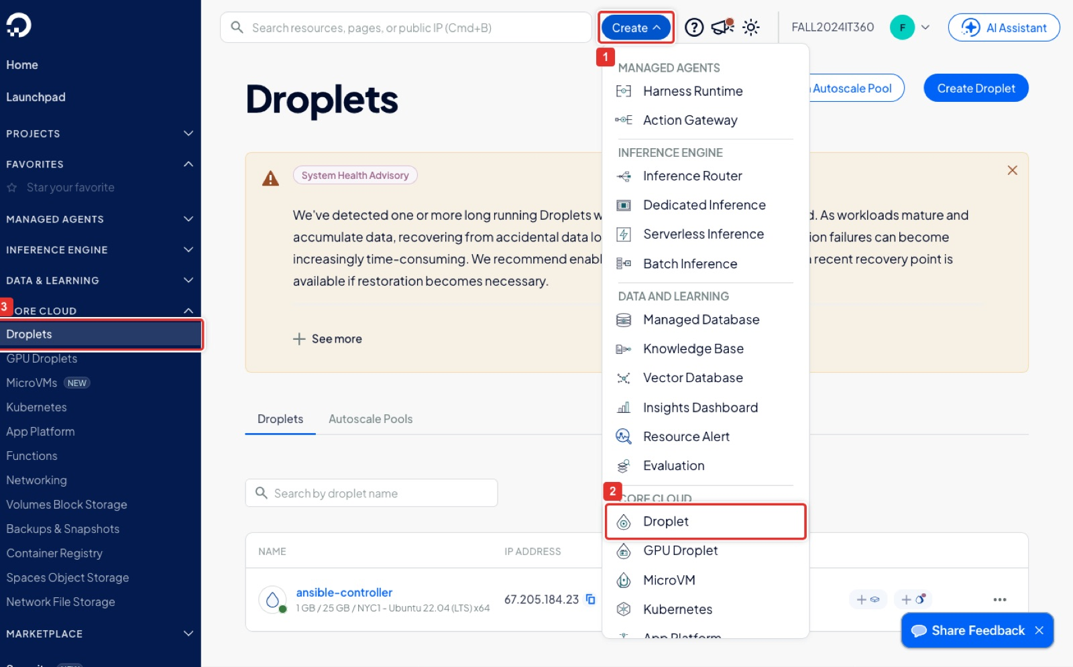
Figure 1. DigitalOcean: Droplets → Create → Droplet.
What you see: The DigitalOcean control panel for the course team. Droplets (3) in the left menu under Core Cloud lists every virtual machine; the blue Create button (1) opens a long menu grouped by product, and Droplet (2) at the top of its Core Cloud section opens the create form. The instructor's list already shows ansible-controller running; yours will be empty. The orange System Health Advisory about backups is informational.
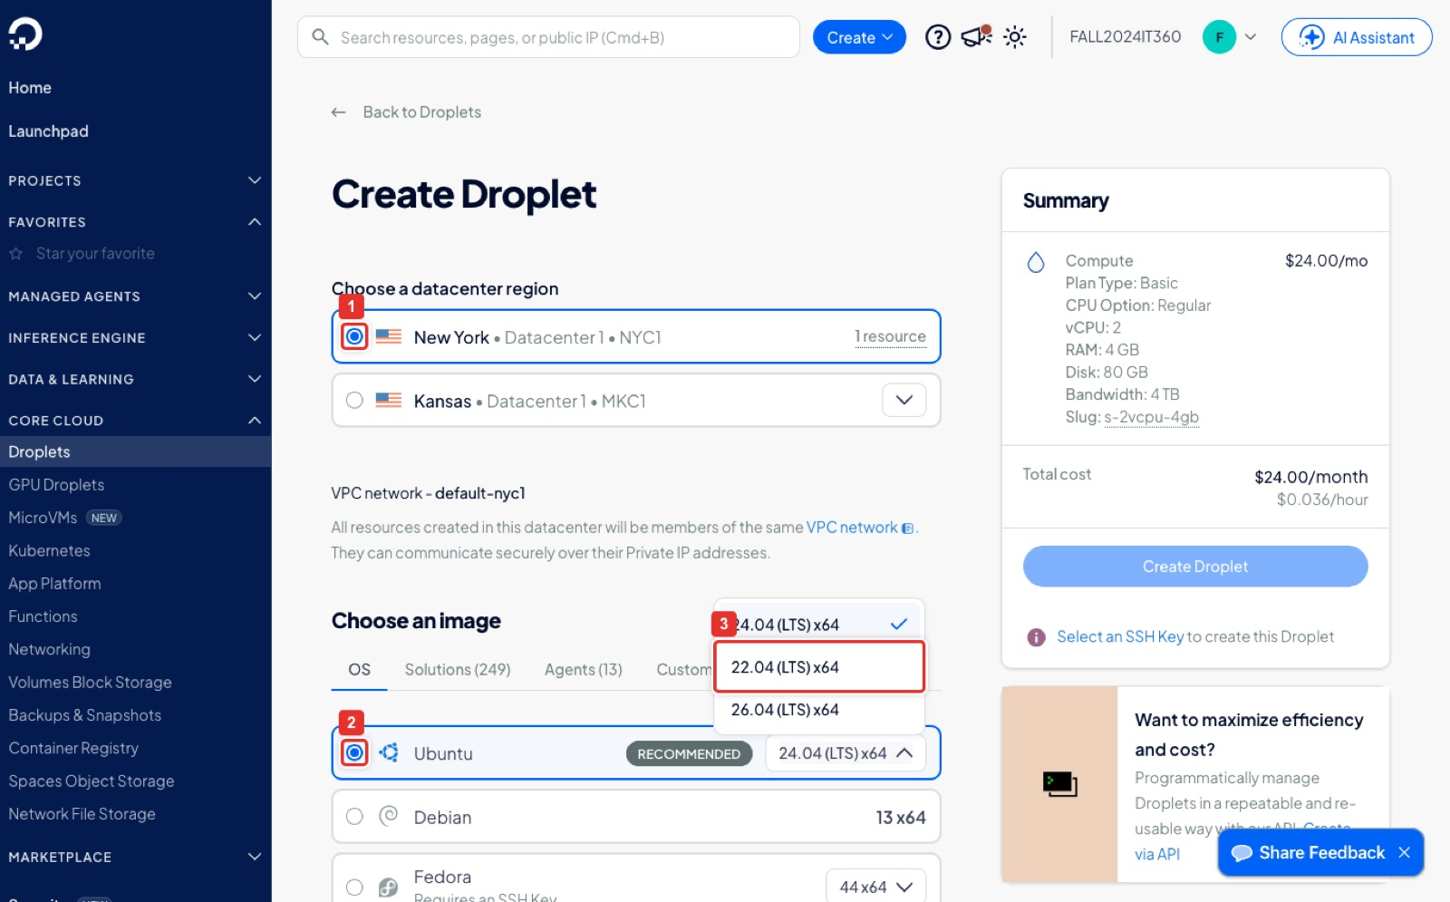
Figure 2. Region New York NYC1, image Ubuntu, version 22.04 (LTS) x64.
What you see: The top of the Create Droplet form. The datacenter radio buttons come first; NYC1 (1) is selected. Under Choose an image the Ubuntu tile (2) is selected and its version dropdown is open: the default is 24.04, so click 22.04 (LTS) x64 (3), which is the release every command in this lab was tested on. The Summary panel on the right updates as you go; ignore its price until the plan is chosen.
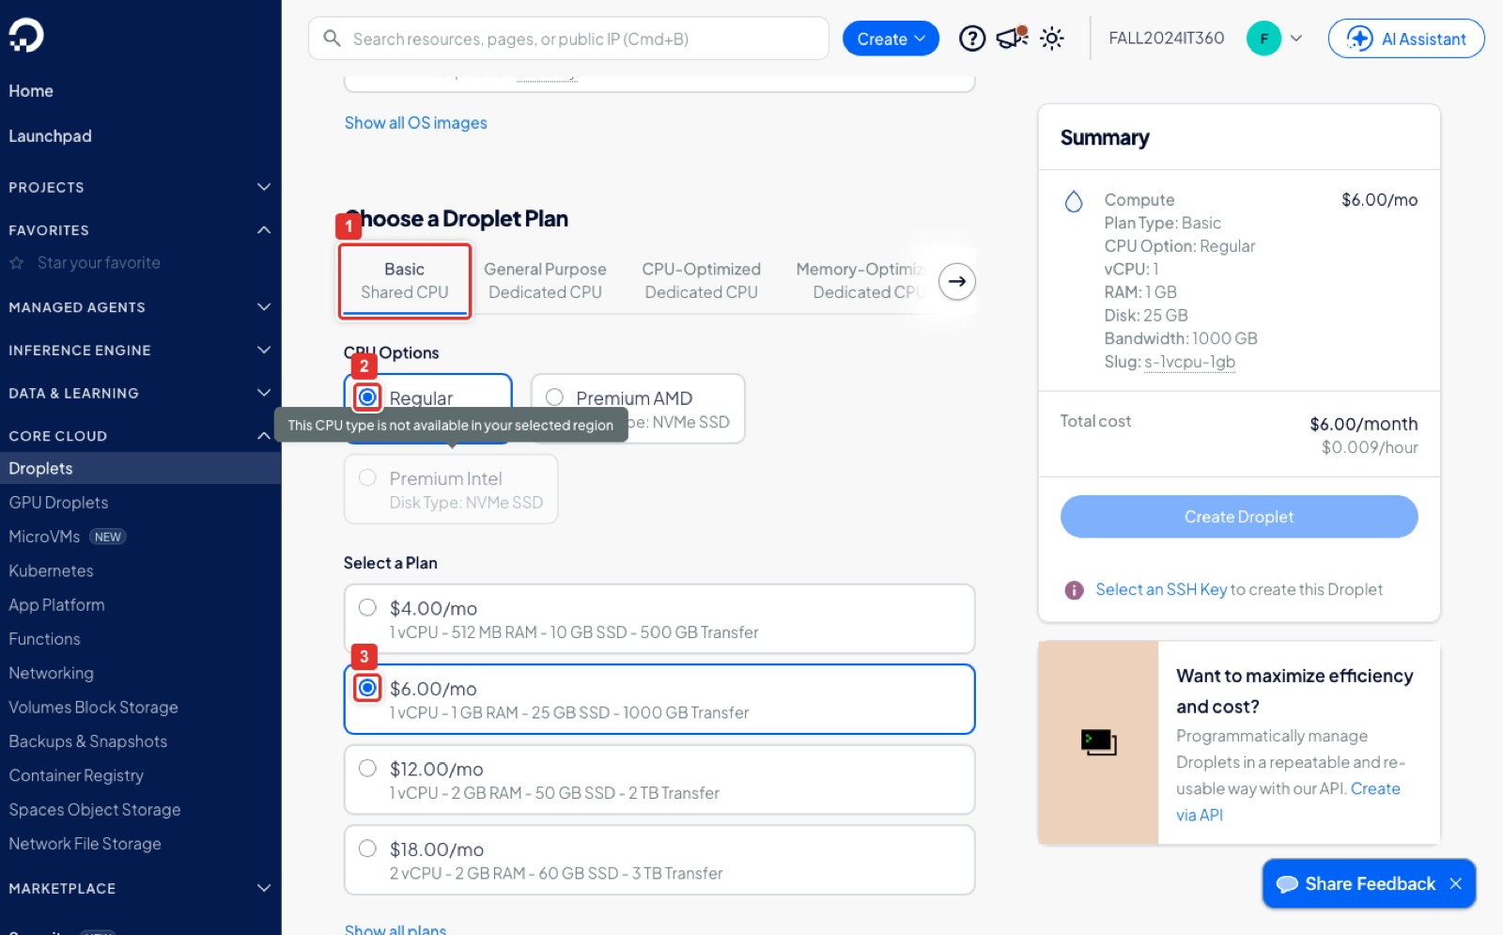
Figure 3. Plan: Basic Shared CPU, Regular, $6/mo (1 vCPU, 1 GB, 25 GB SSD).
What you see: The Choose a Droplet Plan section. The Basic, Shared CPU tab (1) is selected, the CPU option is Regular (2), and the $6.00/mo plan (3) is ticked. The Summary now reads Plan Type Basic, 1 vCPU, 1 GB, slug s-1vcpu-1gb, which is exactly the size the deploy script uses. Premium Intel is greyed out because it is not offered in NYC1; that is normal.
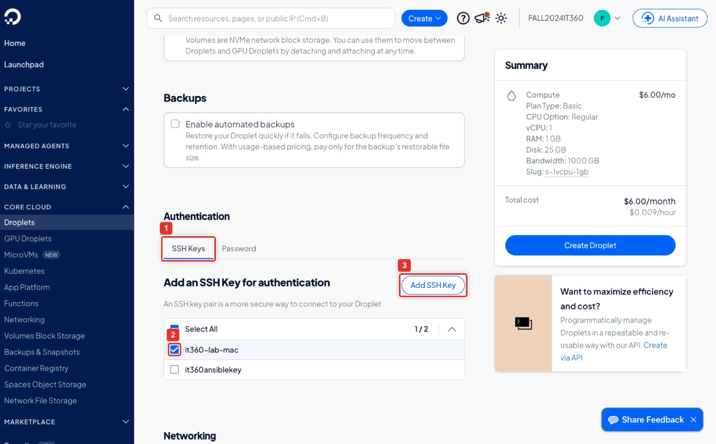
Figure 4. Authentication: SSH Keys, tick your laptop key, or Add SSH Key.
What you see: The Authentication section. The SSH Keys tab (1) is the only safe choice; never use the Password tab for a server on the internet. The list shows the keys already stored in the team account, and it360-lab-mac (2) is ticked; your own key will have whatever name you gave it. Add SSH Key (3) opens the dialog in the next figure when your laptop key is not here yet. The Create Droplet button in the Summary panel turns solid blue only after a key is ticked.
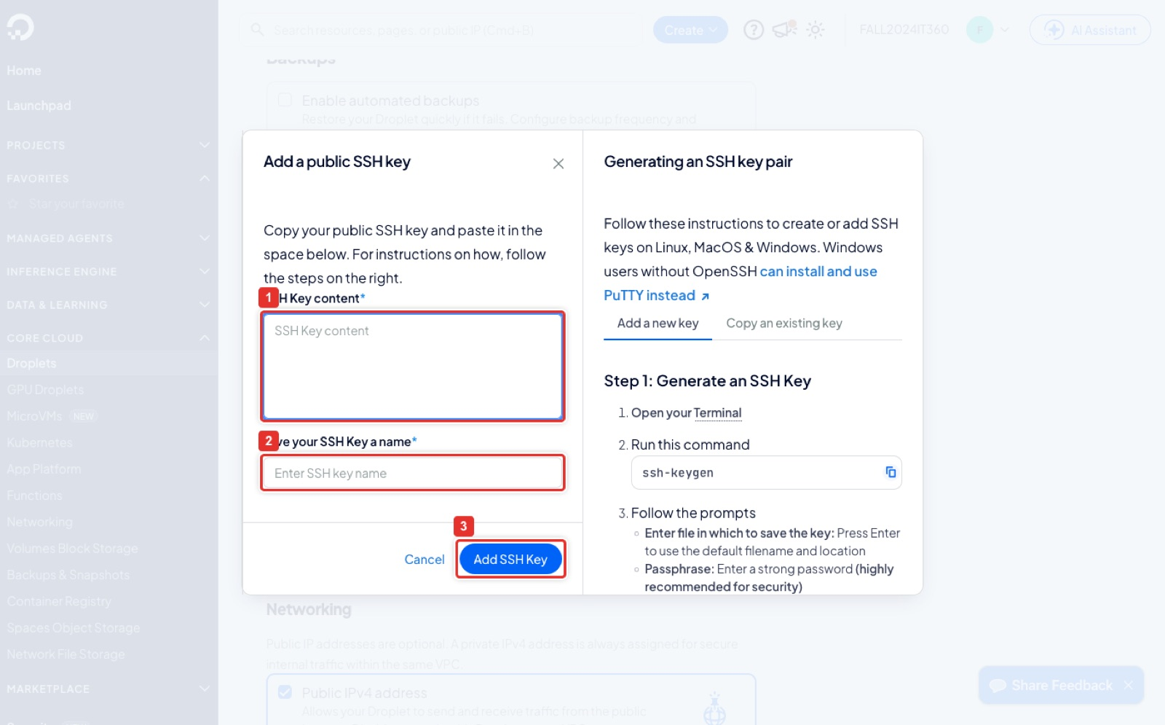
Figure 5. Add a public SSH key: paste the .pub contents, give it a name, Add SSH Key.
What you see: The Add a public SSH key dialog. Paste the whole single line from your laptop's ~/.ssh/id_ed25519.pub into SSH Key content (1), type a name such as my-laptop in Give your SSH Key a name (2), and click Add SSH Key (3). The right half of the dialog is DigitalOcean's own reminder of how to generate a key with ssh-keygen if you do not have one. Paste only the .pub file, never the private key.
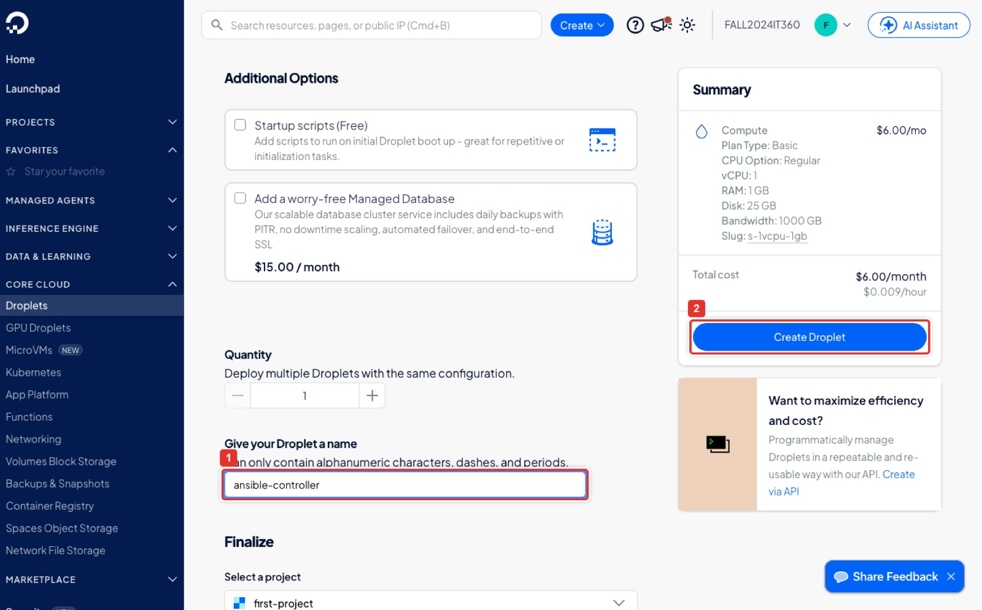
Figure 6. Hostname ansible-controller, then Create Droplet.
What you see: The bottom of the form. Give your Droplet a name (1) holds ansible-controller; DigitalOcean also uses it as the Linux hostname, which is why the prompt later reads root@ansible-controller. Leave Quantity at 1 and the project at its default. Create Droplet (2) in the Summary panel starts the build; the Summary confirms $6.00/month before you click.
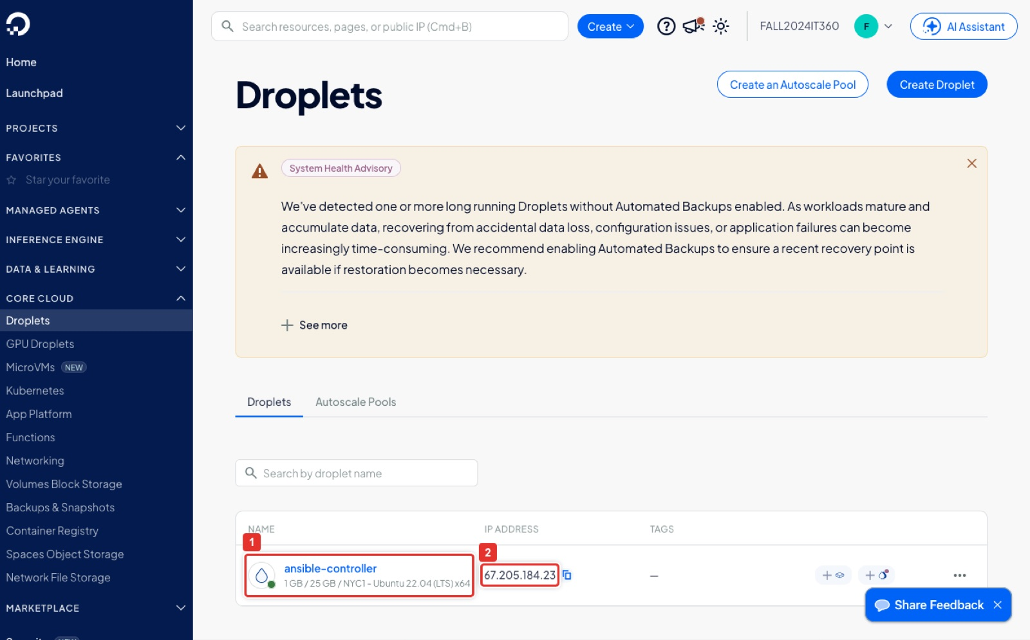
Figure 7. The new droplet in the list with its public IP.
What you see: The Droplets list within about a minute of Create. The row shows the name ansible-controller (1) with its size, region and image underneath, and the public IP address (2) with a copy icon next to it. This IP is CONTROLLER_IP for the rest of the lab. The green dot by the droplet icon means it is powered on.
Terminal on your laptop (same result with doctl, after `doctl auth init`)
doctl compute ssh-key import my-laptop --public-key-file ~/.ssh/id_ed25519.pub # once; prints the key ID
doctl compute ssh-key list
doctl compute droplet create ansible-controller --region nyc1 --size s-1vcpu-1gb \
--image ubuntu-22-04-x64 --ssh-keys <KEY_ID> --wait
doctl compute droplet list --format Name,Region,PublicIPv4,Status # copy the IP

Note
doctl ... --wait reports the droplet active a few seconds before its public IP exists. If the IP column is empty, run the list command again after five seconds. scripts/deploy-lab2.sh polls for it automatically.

Step 1A. Alternative: the controller on AWS EC2 (only if you have no DigitalOcean account)
Do this step instead of Step 1. The controller is an ordinary Ubuntu 22.04 virtual machine, so an EC2 t3.micro in the AWS account you used for Lab 1 works exactly as well as a droplet. The console pages below are the ones you already met in Lab 1 Step 1; the figures were captured for that lab, so they show the name apacheserver1 and the HTTP rule ticked. Type ansible-controller instead and leave HTTP unticked: the controller is never a web server.
Console: where to click
Set the region selector (top right) to US East (Ohio) us-east-2 (Vocareum sandboxes place you in us-east-1; keep whatever region the sandbox opens), open EC2 → Instances, and click Launch instances (1).
Name (2): ansible-controller. Under Application and OS Images click the Ubuntu tile (3). The Quick Start list does not offer plain 22.04, so click Browse more AMIs (4), open the Community AMIs tab (5), paste ubuntu/images/hvm-ssd/ubuntu-jammy-22.04-amd64-server into the search box (6), press Enter, and click Select (7) on the newest image whose Owner is 099720109477 (Canonical).
Instance type (8): t3.micro (t2.micro on Vocareum). Key pair: click Create new key pair (9), name it ansible-controller-key (10), keep RSA and .pem (11), click Create key pair (12). The browser downloads ansible-controller-key.pem; move it to ~/.ssh/ and run chmod 400 ~/.ssh/ansible-controller-key.pem. On Vocareum use the existing vockey instead and download its .pem from the lab panel.
Network settings: leave Create security group selected. Tick Allow SSH traffic from (13) and change the source to My IP (14). Leave Allow HTTP traffic from the internet (15) and HTTPS unticked.
Configure storage: 8 GiB gp2 (16) is enough; leave the volume type as offered. In the Summary panel click Launch instance (17). On the success page click the instance ID and note its Public IPv4 address: that is CONTROLLER_IP for the rest of the lab.

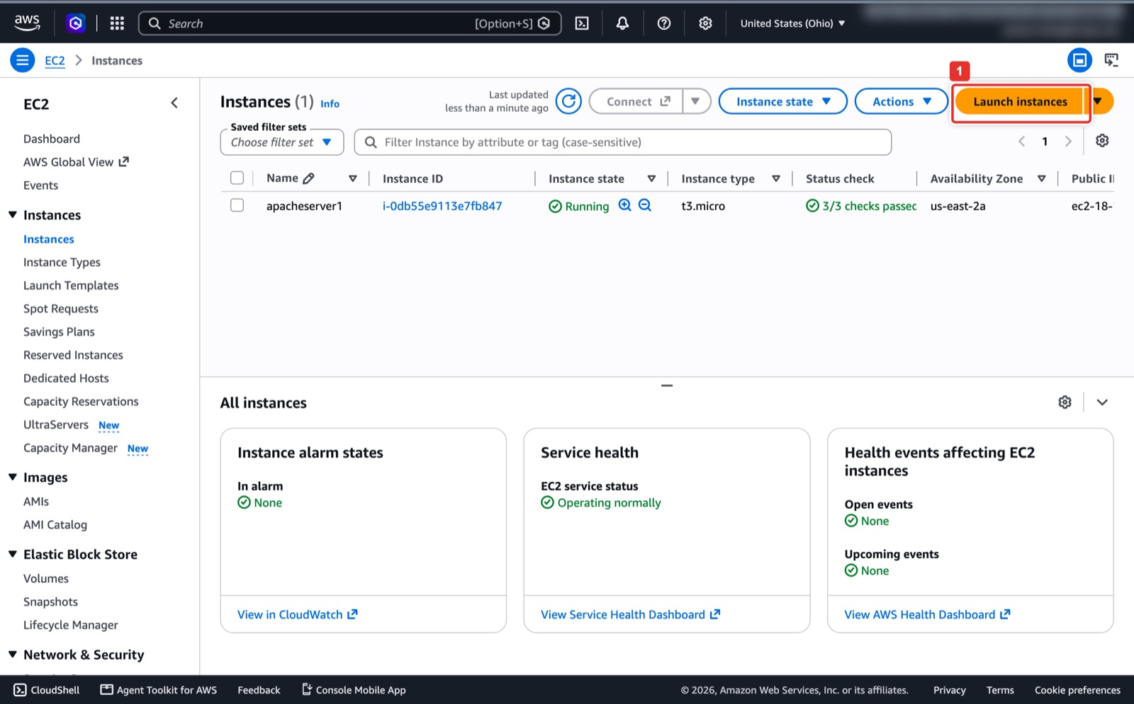
Figure 8. EC2 → Instances → Launch instances.
What you see: The EC2 → Instances page in the Ohio region. The orange Launch instances button (1) opens the wizard. The instructor's list shows the Lab 1 server apacheserver1; yours shows whatever is left from Lab 1, or nothing.
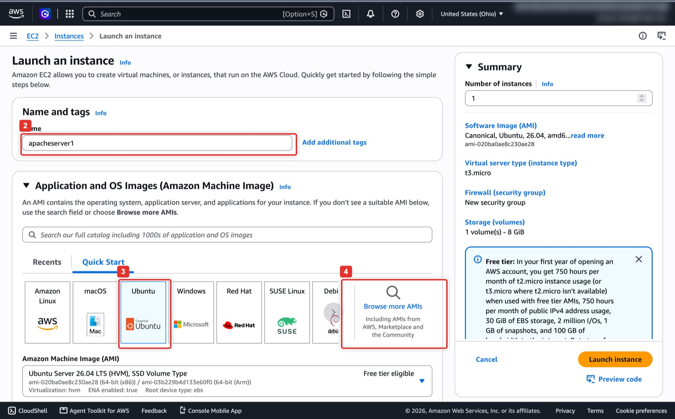
Figure 9. Name the instance, pick the Ubuntu tile, then Browse more AMIs for 22.04.
What you see: The top of the Launch an instance wizard. Name and tags (2) is where you type ansible-controller (the figure still shows the Lab 1 name). The Ubuntu tile (3) is selected, but its dropdown only offers newer releases, so Browse more AMIs (4) is the way to 22.04, the release every command in this lab was tested on.
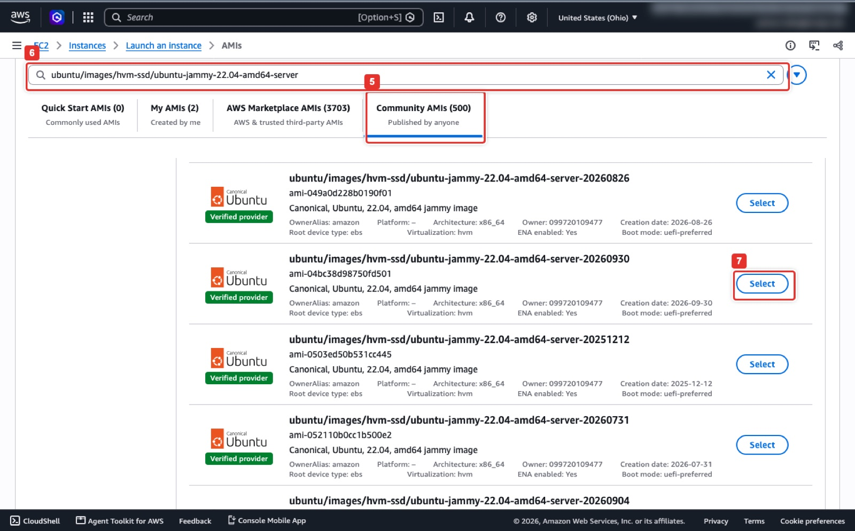
Figure 10. Community AMIs tab, search for the Canonical jammy 22.04 server image, Select the newest one.
What you see: The AMI catalog with the Canonical image name in the search box (6) and the Community AMIs tab (5) showing the matches. Each card lists the AMI ID, Owner 099720109477 and a Creation date; compare the dates and click Select (7) on the newest one. Ignore AWS Marketplace results, which can carry extra charges.
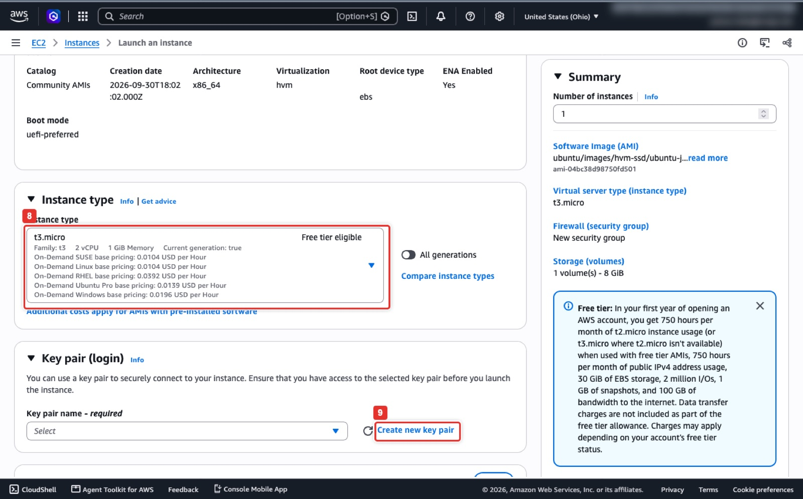
Figure 11. Instance type t3.micro and Create new key pair.
What you see: Further down the wizard. The Instance type box (8) shows t3.micro, free tier eligible, 2 vCPU and 1 GiB, the same size class as the $6 droplet. In Key pair (login) click Create new key pair (9) to open the dialog in the next figure; on Vocareum pick vockey from the dropdown instead.
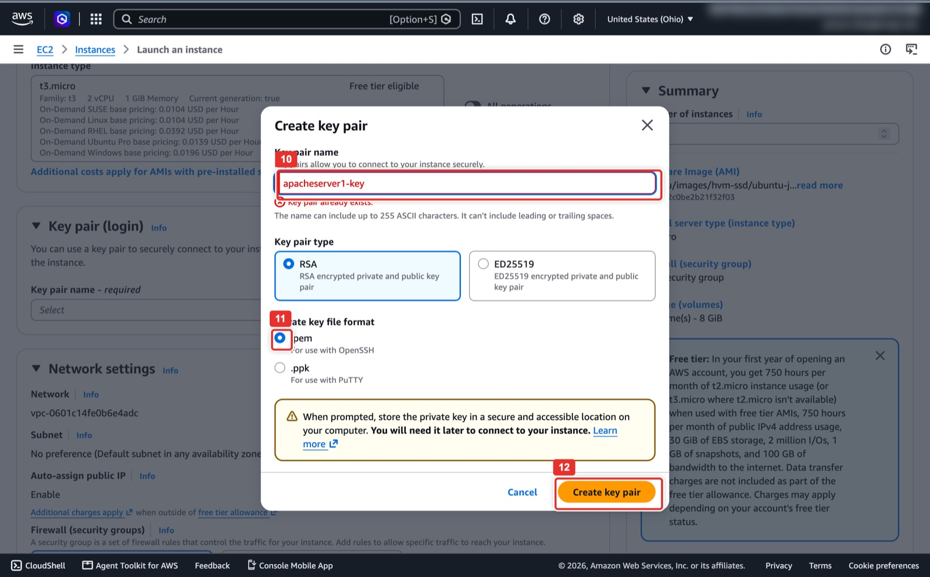
Figure 12. Key pair dialog: name, .pem format, Create key pair.
What you see: The Create key pair dialog. Type ansible-controller-key in Key pair name (10), keep RSA and the .pem format (11), then click Create key pair (12). The browser downloads the .pem file once and AWS never shows it again. This laptop key only logs you in to the controller; the fleet key that Ansible uses is still generated on the controller in Step 3.
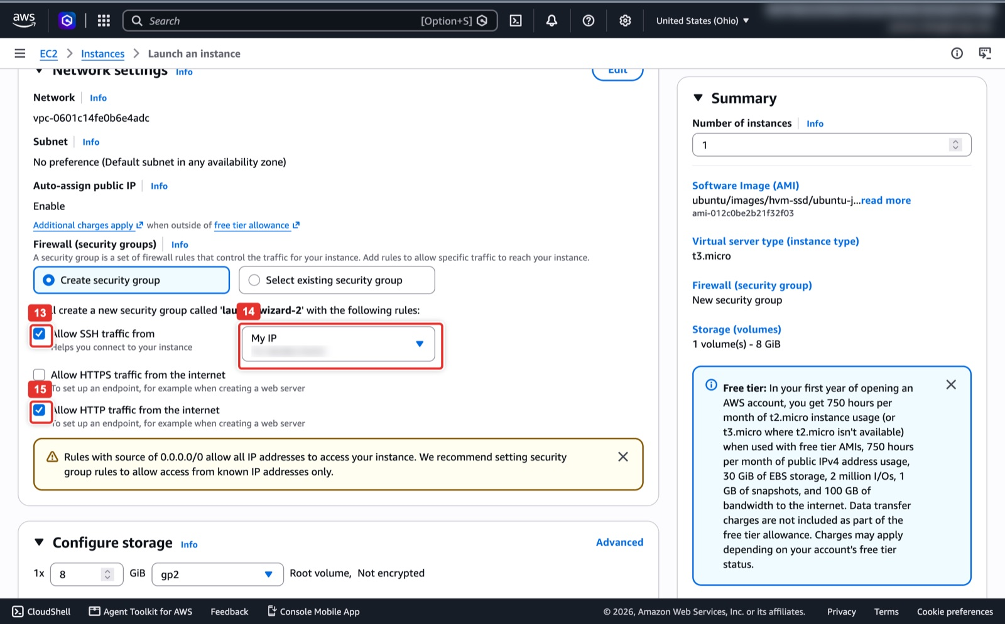
Figure 13. Security group: SSH from My IP only; leave HTTP unticked for the controller.
What you see: Network settings with Create security group selected. Allow SSH traffic from (13) is ticked with the source set to My IP (14), so only your laptop can reach port 22. The figure, taken for Lab 1, also has Allow HTTP traffic from the internet (15) ticked; for the controller leave that box empty, since nothing on it listens on port 80.
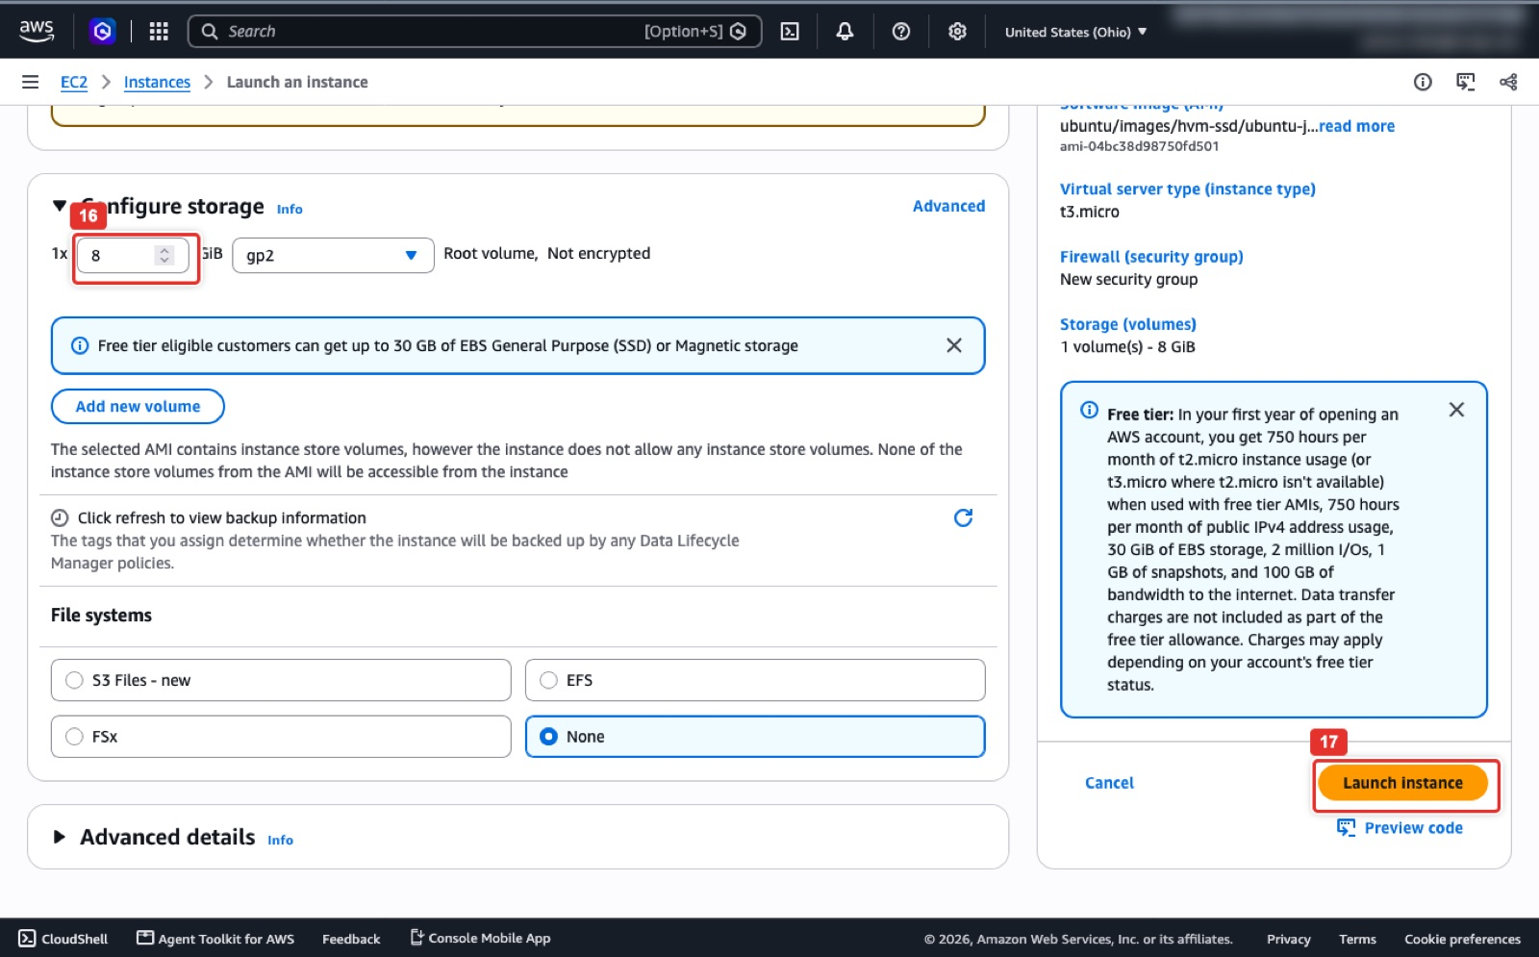
Figure 14. 8 GiB root volume, then Launch instance in the Summary panel.
What you see: Configure storage and the Summary panel. The root volume size field (16) reads 8 GiB, which holds Ubuntu, Ansible and the playbooks with room to spare. When the Summary shows 1 instance, your Ubuntu AMI, t3.micro and a new security group, click Launch instance (17).
Console: where to click
To find the login command: EC2 → Instances, tick ansible-controller (1), click Connect (2), open the In SSH client tab (3) and copy the ssh -i line (4). The user is ubuntu.

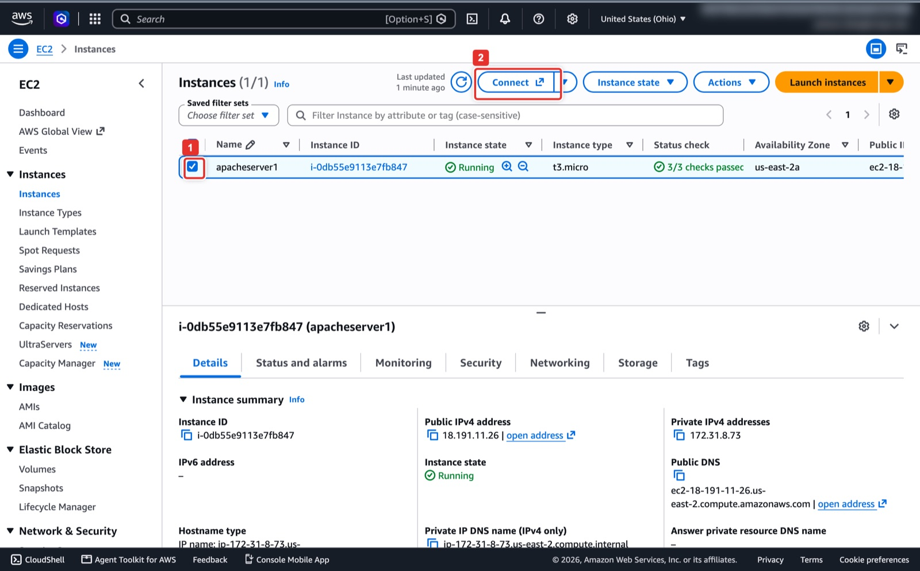
Figure 15. Select the instance and click Connect.
What you see: The Instances page once the new instance is Running with 3/3 checks passed. Tick its checkbox (1); the details pane underneath shows the Public IPv4 address to write down as CONTROLLER_IP. Connect (2) at the top opens the connection page.
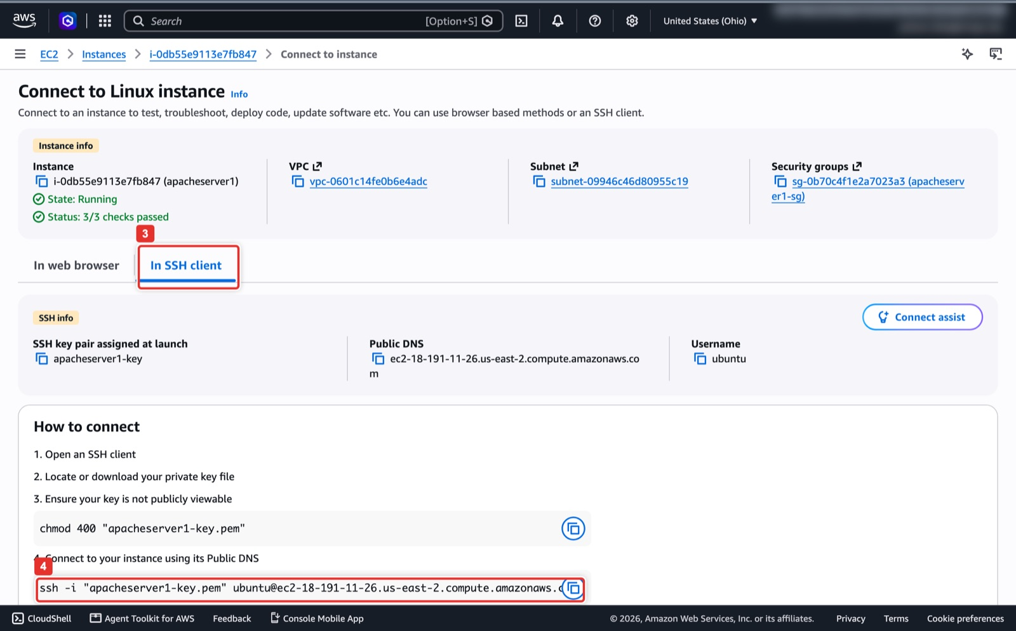
Figure 16. The SSH client tab gives you the ready-made ssh command.
What you see: The Connect to instance page. Its In SSH client tab (3) lists the key pair chosen at launch, the public DNS name and the username ubuntu. The last line (4) is the complete ssh -i command; copy it, replace the key file name with yours if needed, and use it wherever this guide says ssh ... root@ from Step 2 on.
AWS CloudShell (same result; set the region first)
export AWS_DEFAULT_REGION=us-east-2
aws ec2 create-key-pair --key-name ansible-controller-key --query KeyMaterial --output text > ~/.ssh/ansible-controller-key.pem
chmod 400 ~/.ssh/ansible-controller-key.pem
VPC=$(aws ec2 describe-vpcs --filters Name=isDefault,Values=true --query 'Vpcs[0].VpcId' --output text)
SG=$(aws ec2 create-security-group --group-name ansible-controller-sg --description "SSH to the Ansible controller" --vpc-id $VPC --query GroupId --output text)
MYIP=$(curl -s https://checkip.amazonaws.com)
aws ec2 authorize-security-group-ingress --group-id $SG --ip-permissions \
IpProtocol=tcp,FromPort=22,ToPort=22,IpRanges="[{CidrIp=$MYIP/32}]"
AMI=$(aws ec2 describe-images --owners 099720109477 \
--filters 'Name=name,Values=ubuntu/images/hvm-ssd/ubuntu-jammy-22.04-amd64-server-*' 'Name=state,Values=available' \
--query 'sort_by(Images,&CreationDate)[-1].ImageId' --output text)
ID=$(aws ec2 run-instances --image-id $AMI --instance-type t3.micro --key-name ansible-controller-key \
--security-group-ids $SG --associate-public-ip-address \
--tag-specifications 'ResourceType=instance,Tags=[{Key=Name,Value=ansible-controller}]' \
--query 'Instances[0].InstanceId' --output text)
aws ec2 wait instance-running --instance-ids $ID
aws ec2 describe-instances --instance-ids $ID --query 'Reservations[0].Instances[0].PublicIpAddress' --output text # CONTROLLER_IP

Note
Four things differ from the droplet, and nothing else does. User: log in as ubuntu, so every root@ansible-controller:~# prompt in the figures reads ubuntu@ansible-controller:~$ for you. Hostname: EC2 names the machine ip-172-31-x-x; run sudo hostnamectl set-hostname ansible-controller once after you log in so your prompt matches the guide (optional). Fleet key: Step 3 creates it in /home/ubuntu/.ssh/id_rsa instead of /root/.ssh/id_rsa; ~/.ssh/id_rsa in the commands still points to it. SSH from CloudShell: if you created the key pair in CloudShell the .pem lives there, and CloudShell's outgoing IP is not your laptop's, so SSH from the same place you created the key. The Azure NSG rule and the GCP firewall rule in Part B take the EC2 public IP as CONTROLLER_IP exactly as they would a droplet IP.

Expected result
The instance shows Running with 3/3 checks and a public IPv4 address, and ssh -i ~/.ssh/ansible-controller-key.pem ubuntu@<CONTROLLER_IP> gives an Ubuntu 22.04 prompt. Continue with Step 2 and install Ansible with the same commands.

Step 2. Log in and install Ansible
Everything from here to the end of Part A is typed on the controller. Connect as root with the laptop key that you ticked in Step 1; the first connection asks you to confirm the host fingerprint, answer yes. On an AWS controller (Step 1A) connect as ubuntu with the .pem key instead; the install commands below are identical.
Terminal on your laptop
ssh -i ~/.ssh/id_ed25519 root@67.205.184.23
# AWS controller from Step 1A instead:
# ssh -i ~/.ssh/ansible-controller-key.pem ubuntu@<CONTROLLER_IP>

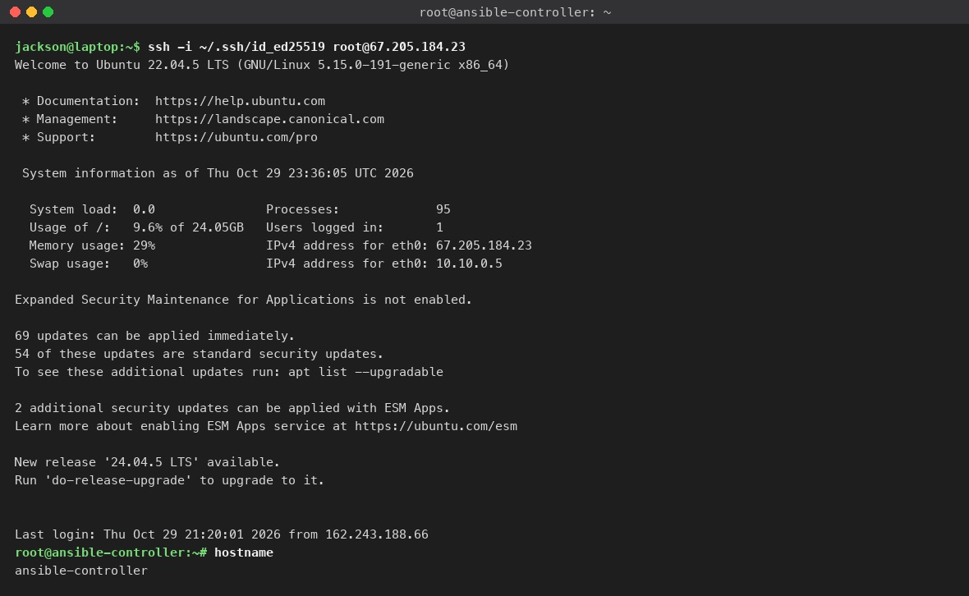
Figure 17. First SSH login to the controller as root.
What you see: The welcome banner Ubuntu prints on every interactive login: the release (22.04.5 LTS), a short system summary that includes the droplet's public IPv4 and private 10.x address, and a note about pending updates, which you can ignore for this lab. The prompt root@ansible-controller:~# is where the next commands go, and hostname confirms you are on the right machine. If you see Permission denied (publickey), you ticked the wrong key in Step 1 or used the wrong -i file.
On the controller
sudo apt update && sudo apt install -y software-properties-common
sudo add-apt-repository --yes --update ppa:ansible/ansible
sudo apt update && sudo apt install -y ansible
ansible --version

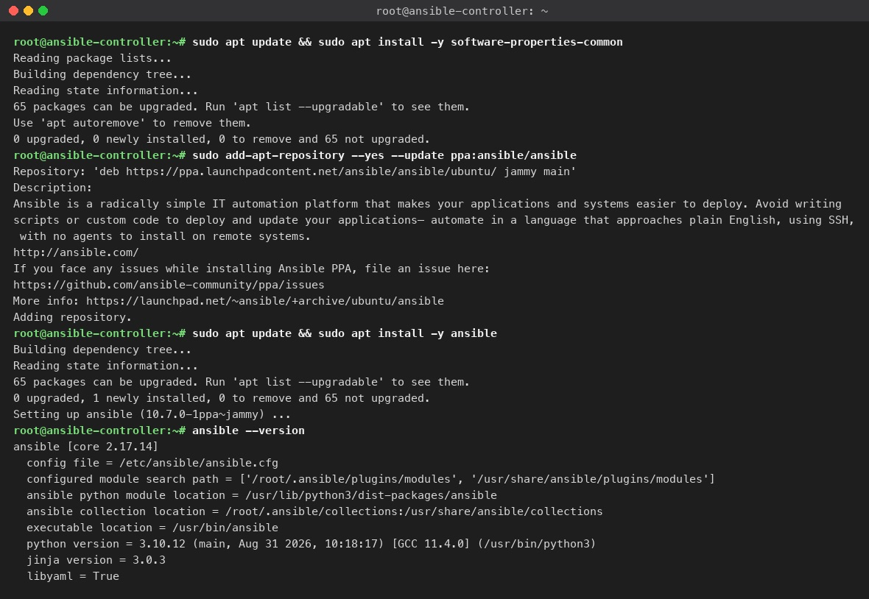
Figure 18. Installing Ansible from the official PPA and checking the version.
What you see: The four install commands and the useful lines of their output. add-apt-repository prints the PPA description and adds it. The second apt install ends with Setting up ansible (10.7.0-1ppa~jammy), and ansible --version reports ansible [core 2.17.14] with Python 3.10. Any 2.1x core version is fine. The full apt output is several screens long; the figure keeps only the lines you should look for.
Expected result
ansible --version prints a version line. That is Checkpoint 1. If the shell says ansible: command not found, run hash -r or open a new SSH session.

Step 3. Generate the fleet SSH key on the controller
This key is what Ansible will use to log in to every client. It is created on the controller and its private half never leaves it. Only the public line is pasted into Google Cloud and Azure in Part B.
On the controller
ssh-keygen -t rsa -b 2048 -N "" -f ~/.ssh/id_rsa
cat ~/.ssh/id_rsa.pub

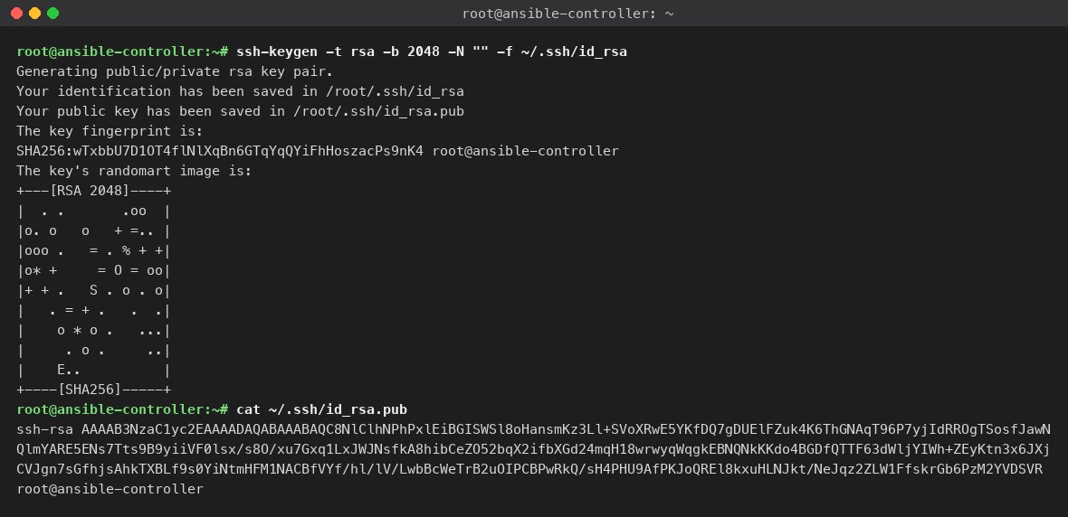
Figure 19. ssh-keygen creates ~/.ssh/id_rsa and the public key you will paste into both clouds.
What you see: ssh-keygen reports where it saved the private key (/root/.ssh/id_rsa) and the public key (/root/.ssh/id_rsa.pub), prints the fingerprint and a randomart picture that you can ignore. cat ~/.ssh/id_rsa.pub prints the one long line that starts with `ssh-rsa` and ends with `root@ansible-controller`: select the whole line, including the comment at the end, and copy it. You will paste it twice, once into each cloud, and nowhere else. -N "" gives the key no passphrase so Ansible can use it without prompting.
Note
The helper scripts/01-controller-bootstrap.sh does Steps 2 and 3 in one go on a droplet: copy it to the controller and run bash 01-controller-bootstrap.sh as root. It calls apt-get without sudo, so on an AWS controller (Step 1A) it only works as root (sudo -i first), and run as root it writes the fleet key to /root/.ssh/id_rsa, not /home/ubuntu/.ssh/id_rsa. On an AWS controller either use the Step 2 and Step 3 commands as ubuntu, or stay root (sudo -i) for every later step so ~/.ssh/id_rsa in the inventory points at that key.

Part B. The two client VMs (20 min, do both clouds)
Both clients are plain Ubuntu 22.04 servers with ports 22 and 80 open and the controller's public key installed for user ubuntu. The two consoles ask for the same five things in different places: a name, a region, the image, the size, and the SSH key.

Step 4. Google Cloud client
Console: where to click
Open Compute Engine → VM instances in your own project and click Create instance (1).
Machine configuration: Name (1) ansible-client-gcp, Region (2) us-central1 (Iowa), Zone (3) us-central1-a. In the machine series table tick E2 (4), then open the Machine type dropdown (5) and choose e2-micro (0.25-2 vCPU, 1 GB).
OS and storage (left menu) → Change. In the Boot disk panel stay on Public images (1), set Operating system (2) to Ubuntu, open Version (3), type 22.04 in the filter and choose Ubuntu 22.04 LTS x86/64 (4), then click Select (5).
Networking (6): tick Allow HTTP traffic (7), which adds the http-server tag, and add the network tag ansible-client (8). Then click Create (9) at the bottom.
When the VM is running, open it, click Edit, scroll to SSH Keys (1), click Add item (3), paste the controller's ssh-rsa ... root@ansible-controller line into the box (2) and change the comment at the end of the line from root@ansible-controller to `ubuntu` (GCP uses that word as the login name). Click Save (4).
VPC network → Firewall: confirm a rule allows tcp:22 to the VM (default-allow-ssh) and one allows tcp:80 to the http-server tag (default-allow-http). Create them only if your project does not have them. Record the VM's External IP as GCP_IP.

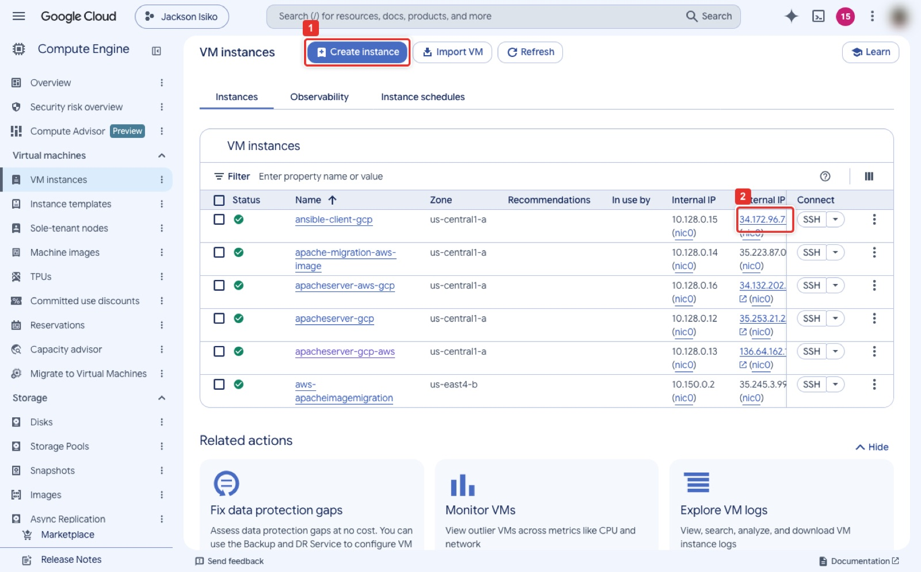
Figure 20. Compute Engine → VM instances → Create instance.
What you see: The VM instances page of the instructor's project. Create instance (1) at the top opens the form. The running ansible-client-gcp row shows its zone, internal IP and External IP (2), which is the address Ansible will use; your list will show only the VMs you created. The other rows are Lab 1 servers and do not matter here.
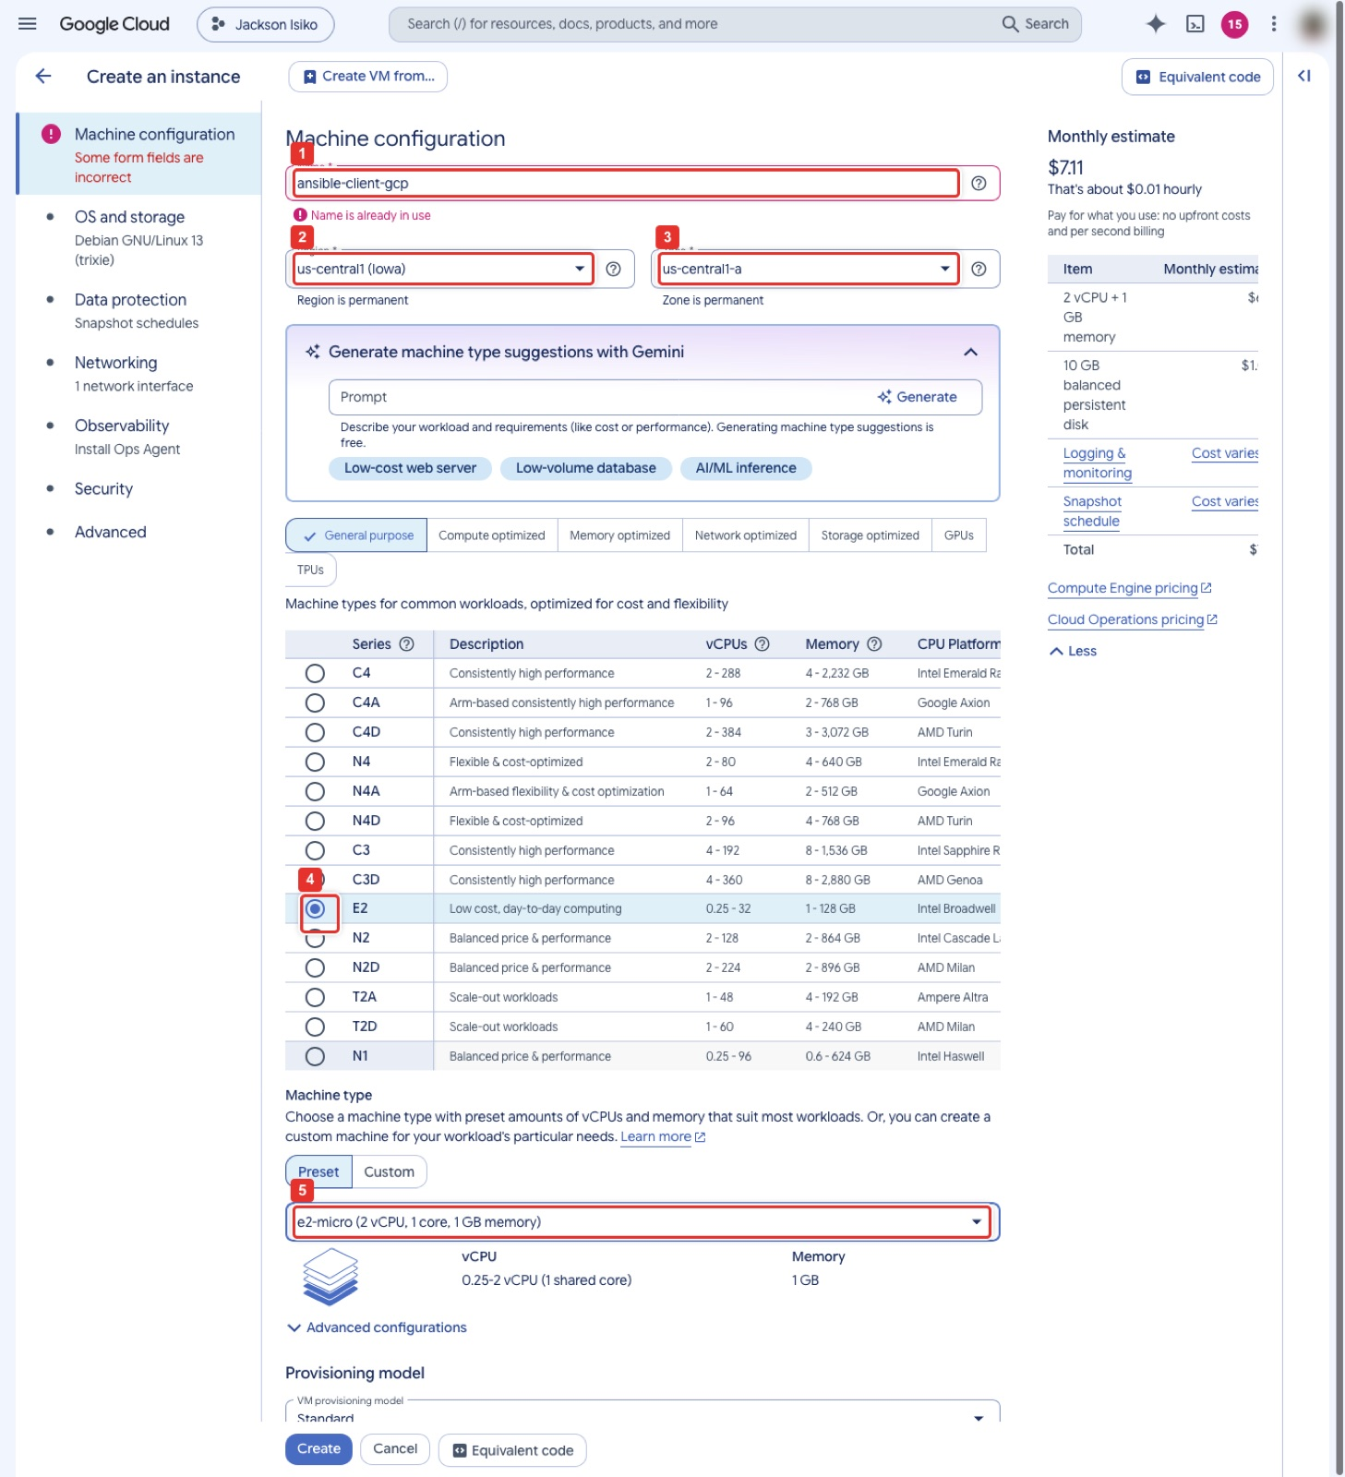
Figure 21. Machine configuration: name, region, zone, E2 series, e2-micro.
What you see: The first step of the Create an instance form. Name (1) holds ansible-client-gcp; the red Name is already in use message appears only because the instructor's VM exists, you will not see it. Region (2) is us-central1 and Zone (3) us-central1-a; both are permanent once created. In the series table E2 (4) is ticked, and the Machine type dropdown (5) reads e2-micro, 2 vCPU, 1 core, 1 GB memory. The Monthly estimate on the right drops to about $7 when e2-micro is chosen.
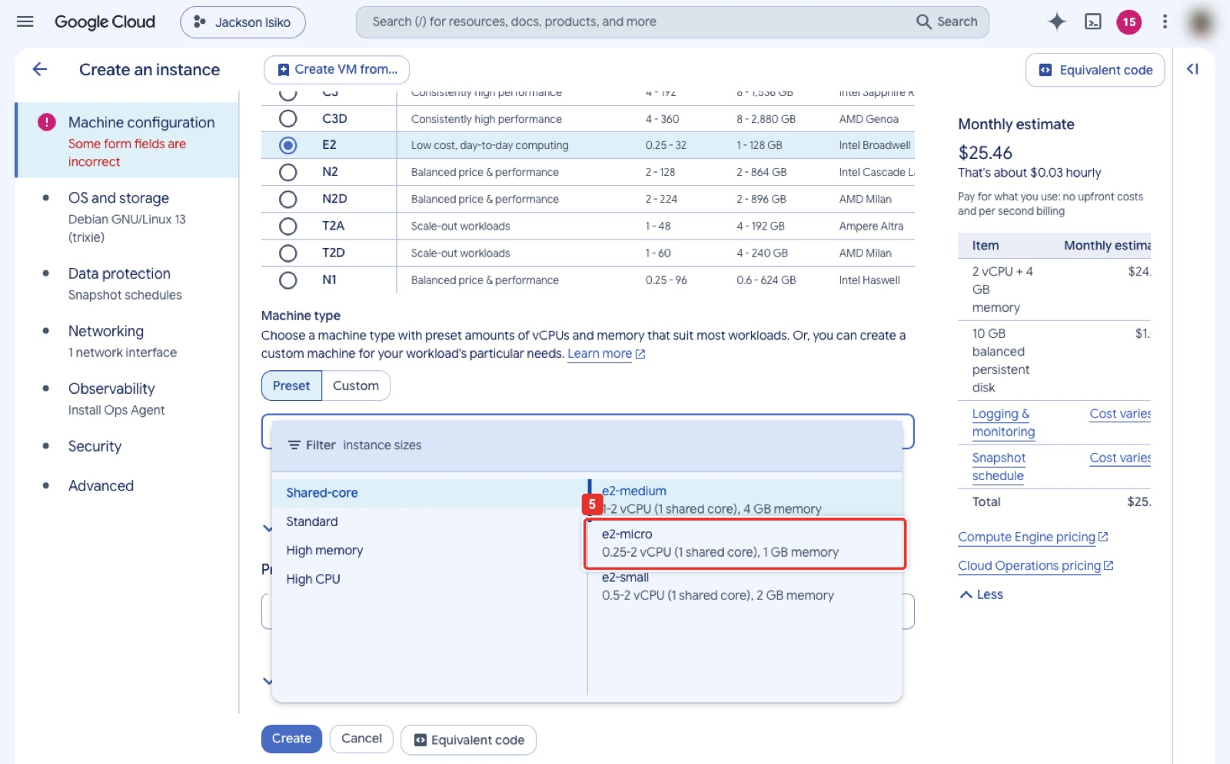
Figure 22. Machine type dropdown: Shared-core → e2-micro.
What you see: The Machine type dropdown open. The left column lists categories; Shared-core is selected and the right column lists e2-medium, e2-micro (5) and e2-small. Click e2-micro. The estimate on the right still shows the e2-medium price until you do.
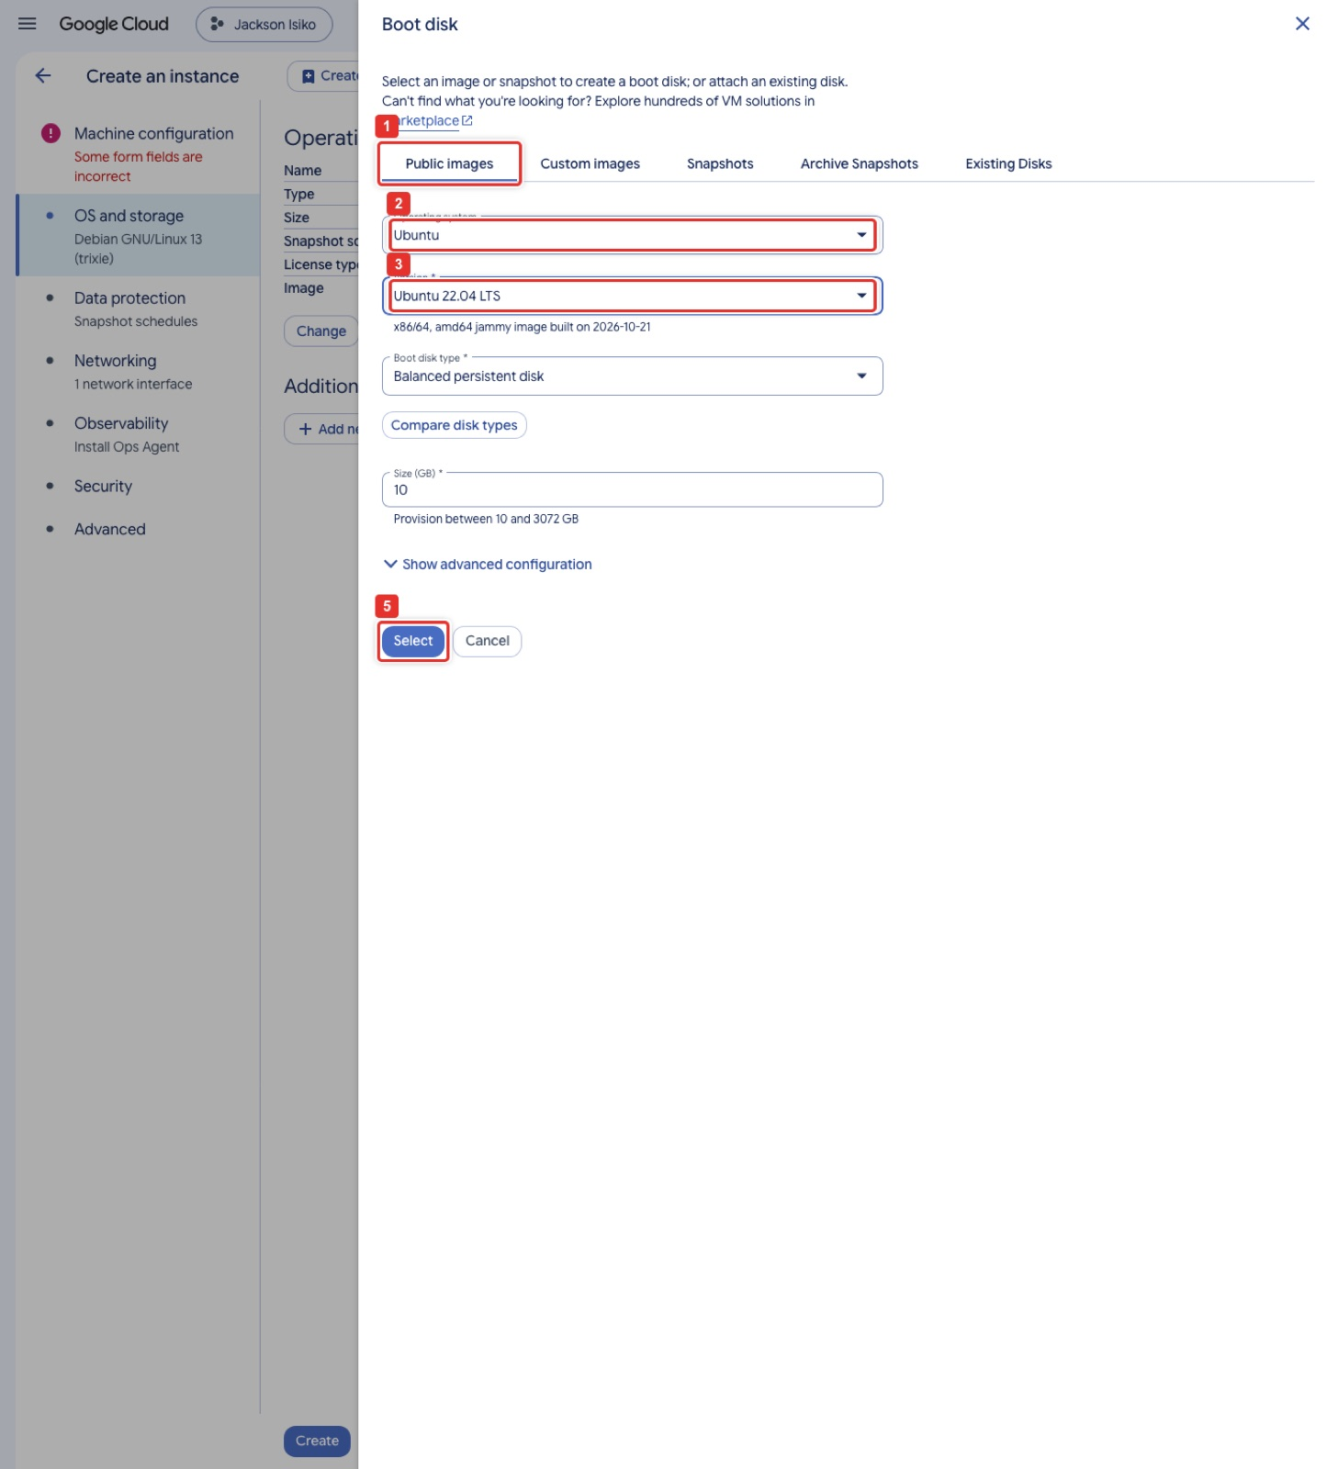
Figure 23. Boot disk panel: Public images, Ubuntu, Ubuntu 22.04 LTS, Select.
What you see: The Boot disk side panel that opens from OS and storage → Change. Public images (1) is the tab for Google's stock images. Operating system (2) is set to Ubuntu and Version (3) to Ubuntu 22.04 LTS, with the small line underneath confirming x86/64, amd64 jammy. Leave the Boot disk type and the 10 GB size as they are, then click Select (5) to return to the form.
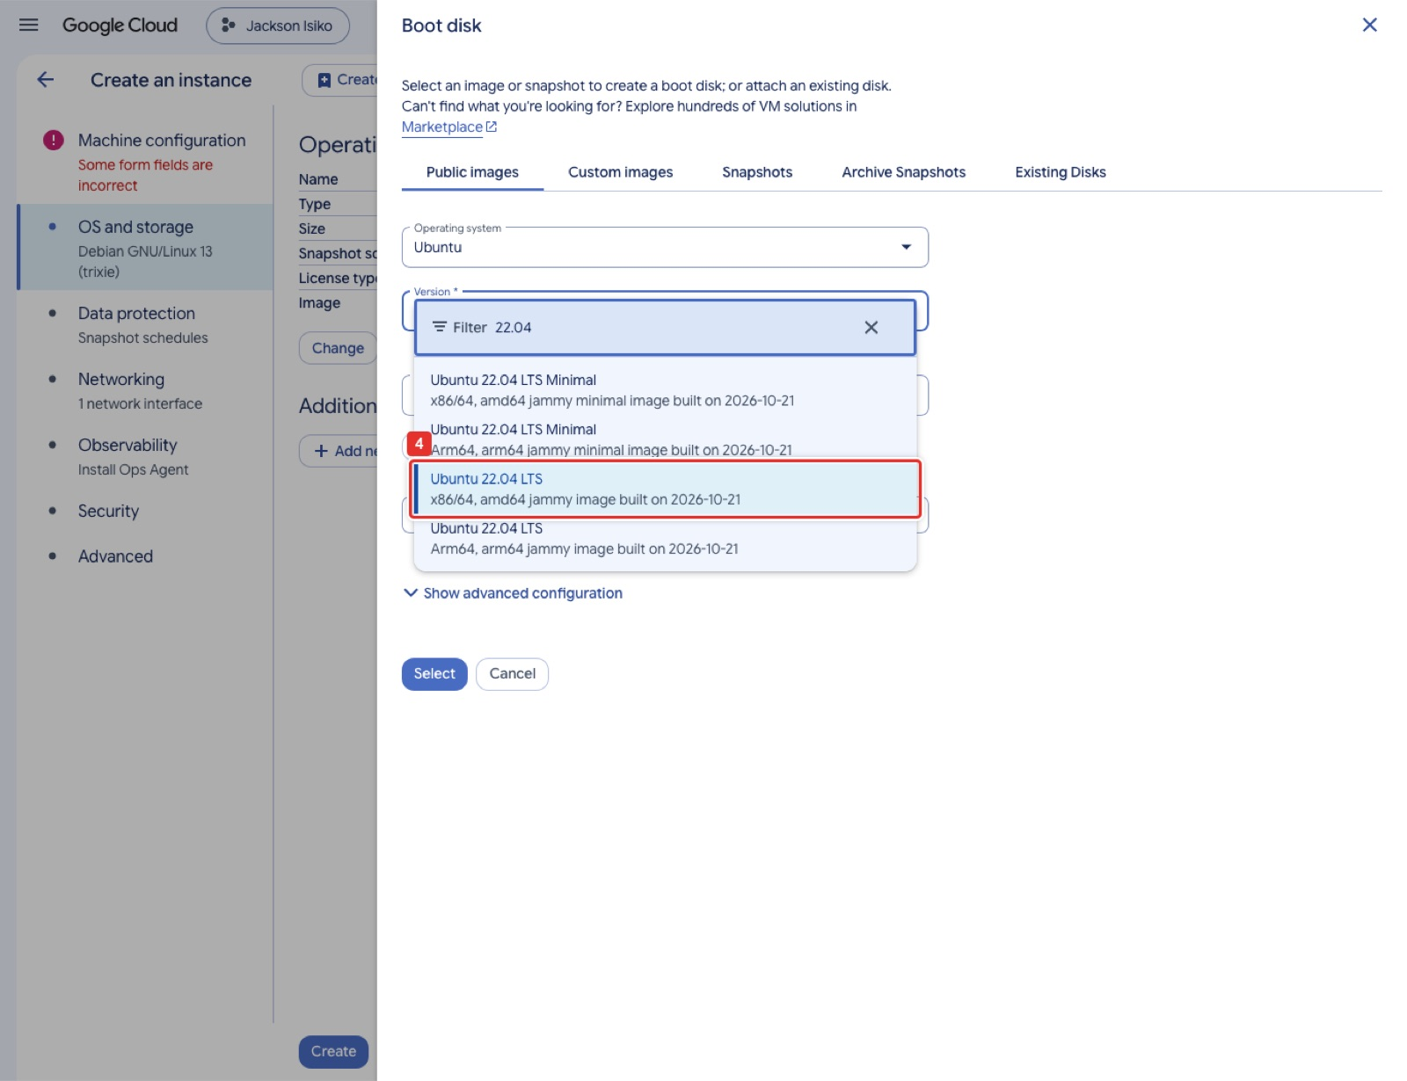
Figure 24. Version list filtered on 22.04: pick the x86/64 image, not Minimal and not Arm64.
What you see: The Version dropdown with 22.04 typed in its filter box. Four images match: two Minimal builds and two full builds, each in x86/64 and Arm64. Choose Ubuntu 22.04 LTS, x86/64 (4). Minimal images lack tools such as curl, and the Arm64 image does not boot on an e2-micro.
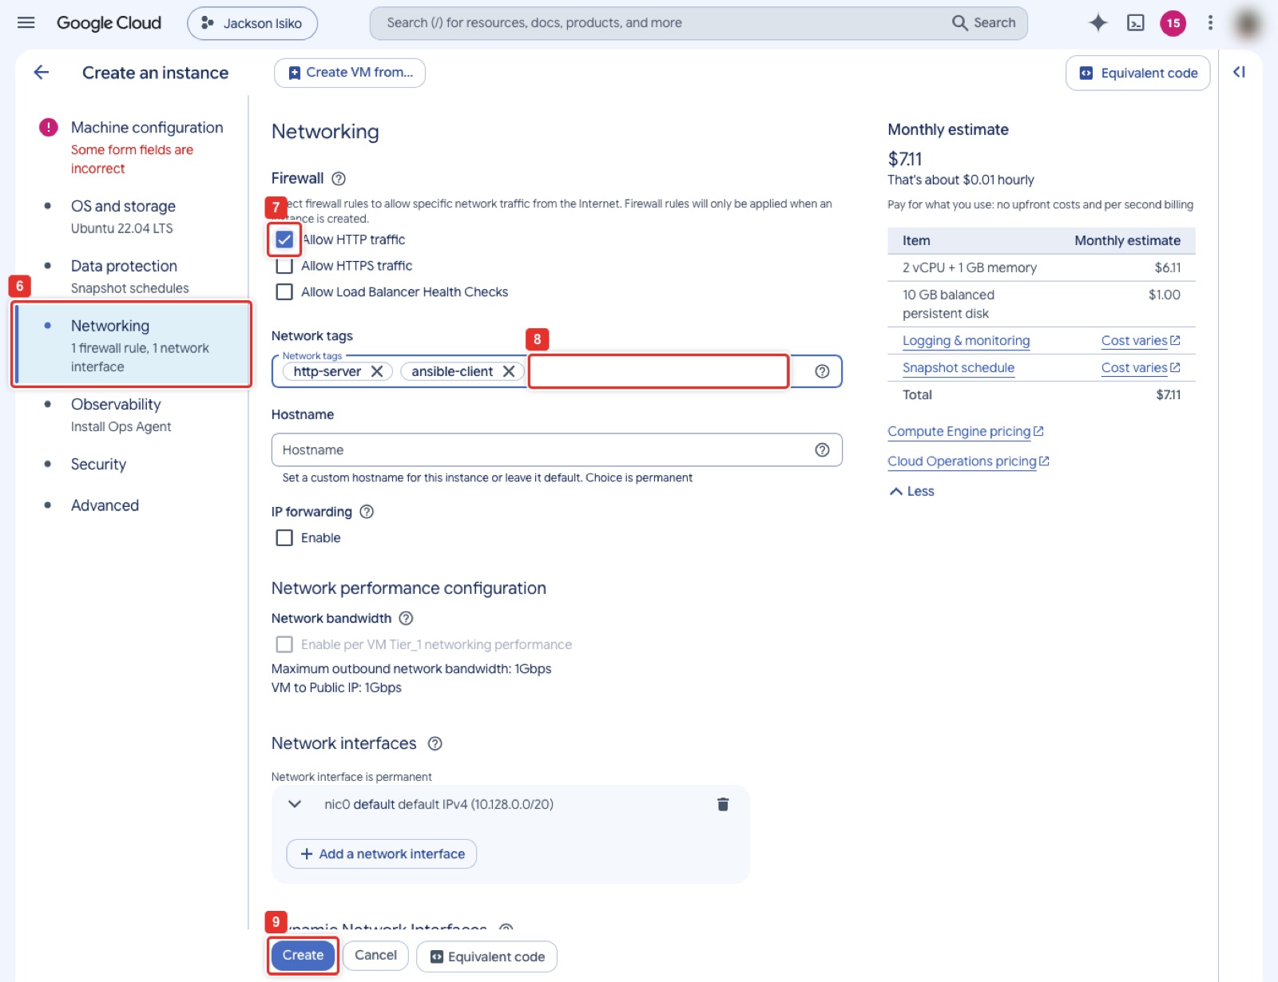
Figure 25. Networking: Allow HTTP traffic, network tag ansible-client, Create.
What you see: The Networking step (6). Ticking Allow HTTP traffic (7) adds the http-server tag, which the project's default-allow-http rule matches, so port 80 is open the moment the VM boots. The Network tags field (8) shows http-server and the extra ansible-client tag; the tag does nothing by itself but lets you write a firewall rule for just the Ansible clients. Create (9) at the bottom builds the VM; it is running in about 30 seconds.
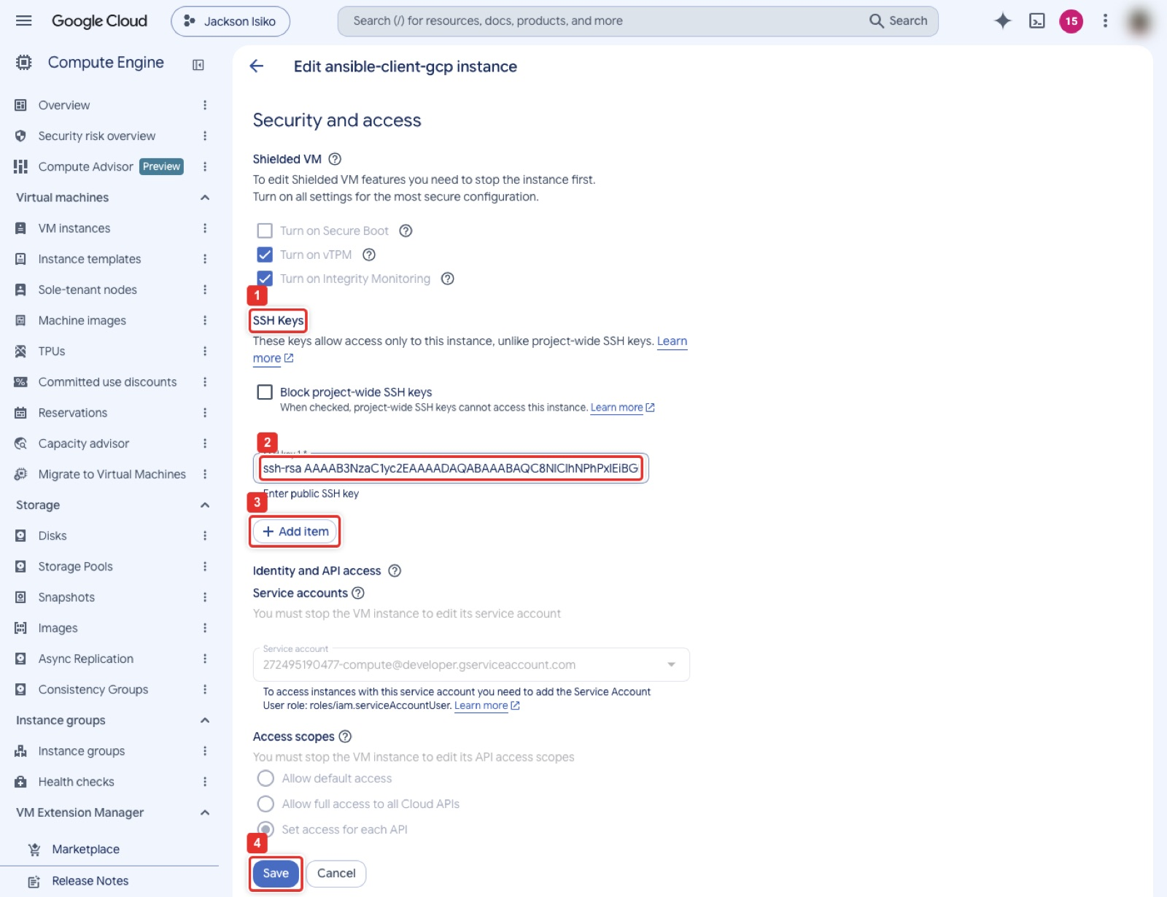
Figure 26. Edit the VM: SSH Keys → Add item → paste the controller key with the comment ubuntu → Save.
What you see: The Edit page of ansible-client-gcp, scrolled to Security and access. Under SSH Keys (1) the box (2) already holds the controller's key because the instructor added it; on a new VM the box is empty and you click Add item (3) to get one. Paste the single ssh-rsa line and make sure it ends with ubuntu rather than root@ansible-controller: Google creates a Linux user named after that comment and installs the key for it. Save (4) is at the very bottom of the page.
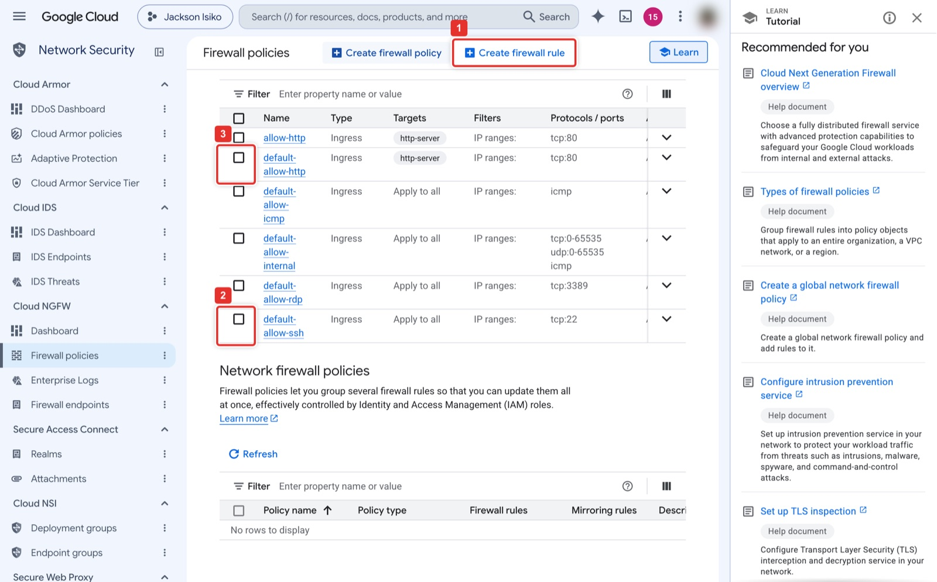
Figure 27. VPC network → Firewall: default-allow-ssh (tcp:22) and default-allow-http (tcp:80 to http-server).
What you see: The Firewall policies page listing the VPC firewall rules of the default network. default-allow-ssh (2) allows tcp:22 from any address to every VM, and default-allow-http (3) allows tcp:80 to VMs tagged http-server. Both exist in a normal project; if either is missing, Create firewall rule (1) makes it. The allow-http rule at the top is left over from Lab 1.
Google Cloud Shell or gcloud on your laptop (same result)
gcloud config set project <PROJECT_ID>
gcloud compute instances create ansible-client-gcp --zone=us-central1-a --machine-type=e2-micro \
--image-family=ubuntu-2204-lts --image-project=ubuntu-os-cloud --tags=http-server,ansible-client
# port 22 and 80 rules only if the project does not have default-allow-ssh / default-allow-http
gcloud compute firewall-rules create allow-ssh-ansible --network=default --direction=INGRESS \
--action=ALLOW --rules=tcp:22 --source-ranges=67.205.184.23/32 --target-tags=ansible-client
gcloud compute firewall-rules create default-allow-http --network=default --direction=INGRESS \
--action=ALLOW --rules=tcp:80 --source-ranges=0.0.0.0/0 --target-tags=http-server
# controller key for user ubuntu (controller_id_rsa.pub is the line from Step 3)
printf 'ubuntu:%s\n' "$(cat controller_id_rsa.pub)" > gcp-ssh-keys.txt
gcloud compute instances add-metadata ansible-client-gcp --zone=us-central1-a --metadata-from-file ssh-keys=gcp-ssh-keys.txt
gcloud compute instances list --filter=name=ansible-client-gcp --format="value(networkInterfaces[0].accessConfigs[0].natIP)"

Step 5. Azure client
Console: where to click
Open Virtual machines in the Azure portal, click Create (1) and choose Virtual machine (2).
Basics, Project details: Subscription is your subscription; Resource group (2): click Create new (3), type ansible-lab-rg (4), OK (5). (Vocareum: pick the pre-created group from the dropdown instead.)
Instance details: Virtual machine name (4) ansible-client-azure, Region (5) (US) East US, Availability options No infrastructure redundancy required. Image (6): the quick list only offers Ubuntu 24.04, so click See all images (7), search for Ubuntu 22.04 LTS Canonical (8), find the card Ubuntu 22.04 LTS - all plans including Ubuntu Pro by Canonical (9), open its Select menu and pick Ubuntu Server 22.04 LTS - x64 Gen 2 (10).
Size: click See all sizes, search B1s (11), expand the B-Series group, click the B1s row (12) and Select (13). If B1s is refused in your region, D2s_v4 also works.
Administrator account: Authentication type SSH public key (14), Username ubuntu (15), SSH public key source Use existing public key (16), and paste the controller's ssh-rsa ... line into Public key (17). Inbound port rules: Allow selected ports with SSH (22) and HTTP (80) (18).
Click Review + create (19), check that validation passed, then Create (20). Deployment takes about a minute. On the VM's Overview page record the Public IP address as AZURE_IP.

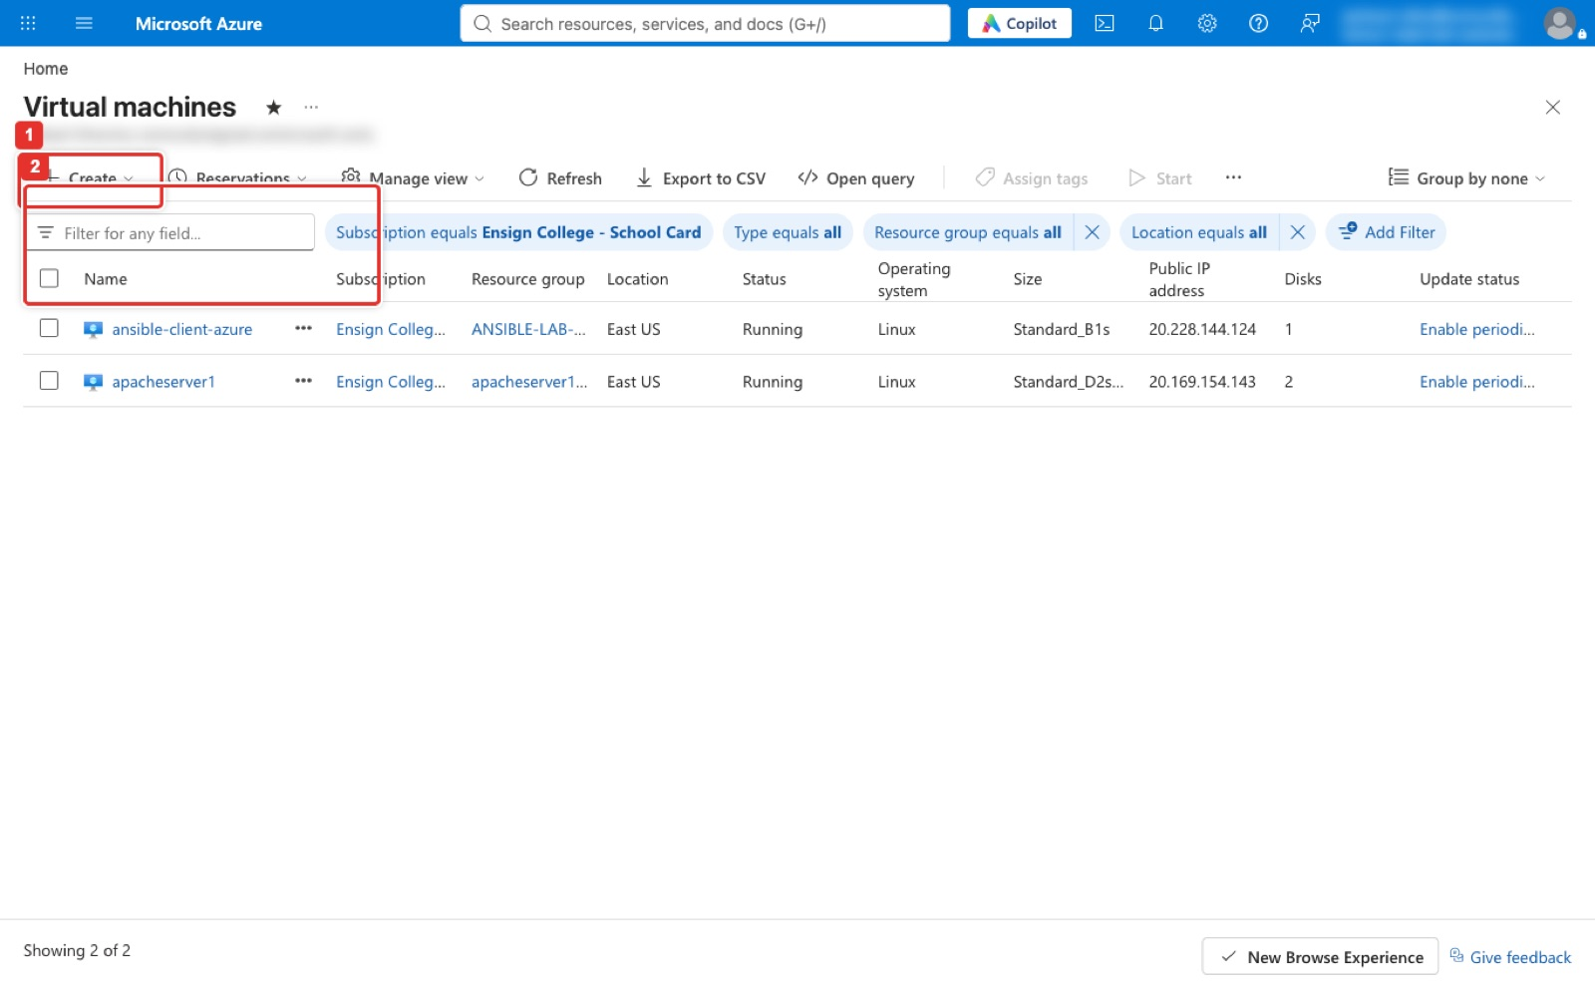
Figure 28. Azure portal: Virtual machines → Create → Virtual machine.
What you see: The Virtual machines list of the instructor's subscription, filtered to the Ensign College subscription. Create (1) opens a short menu whose first item is Virtual machine; the figure was taken with the menu closed, so mark 2 sits where that item appears once the menu is open. The rows in the list are the running ansible-client-azure and a Lab 1 server; your list starts empty.
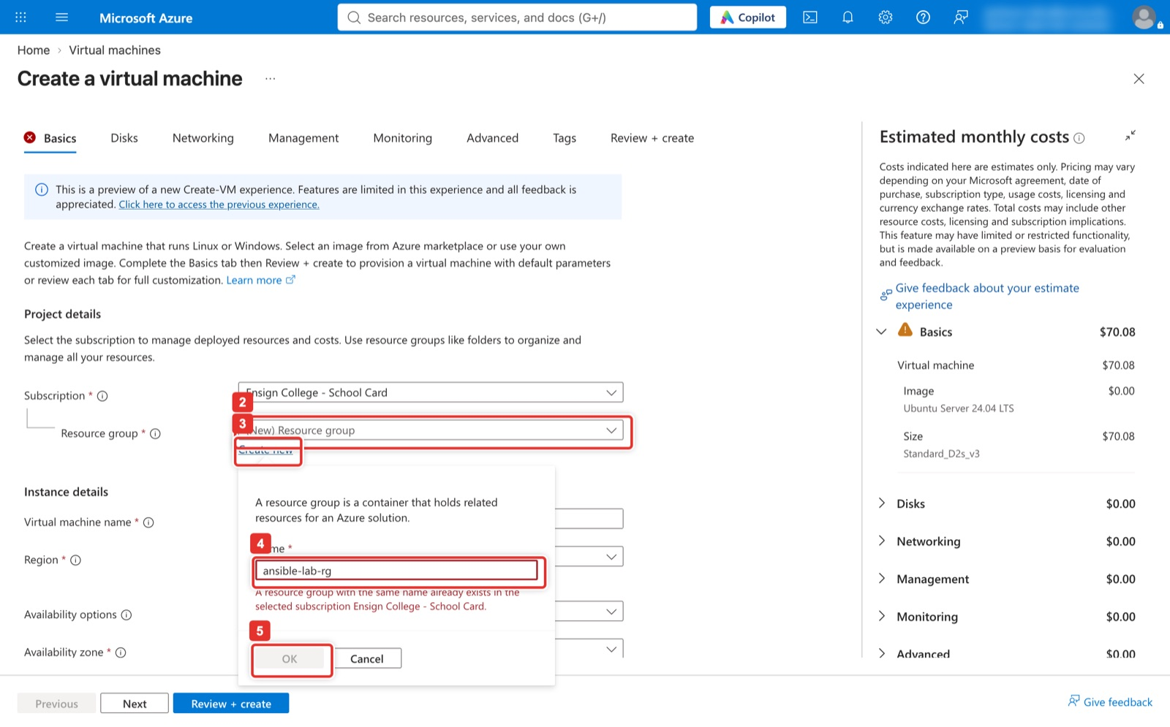
Figure 29. Basics: Resource group → Create new → name → OK.
What you see: The Project details section of the Basics tab. The Resource group dropdown (2) lists existing groups; Create new (3) under it opens the small popover where you type the name (4) and click OK (5). The red message under the box appears only because ansible-lab-rg already exists in the instructor's subscription; on your first run the OK button is enabled. A resource group is the folder Azure deletes as a whole in Part F.
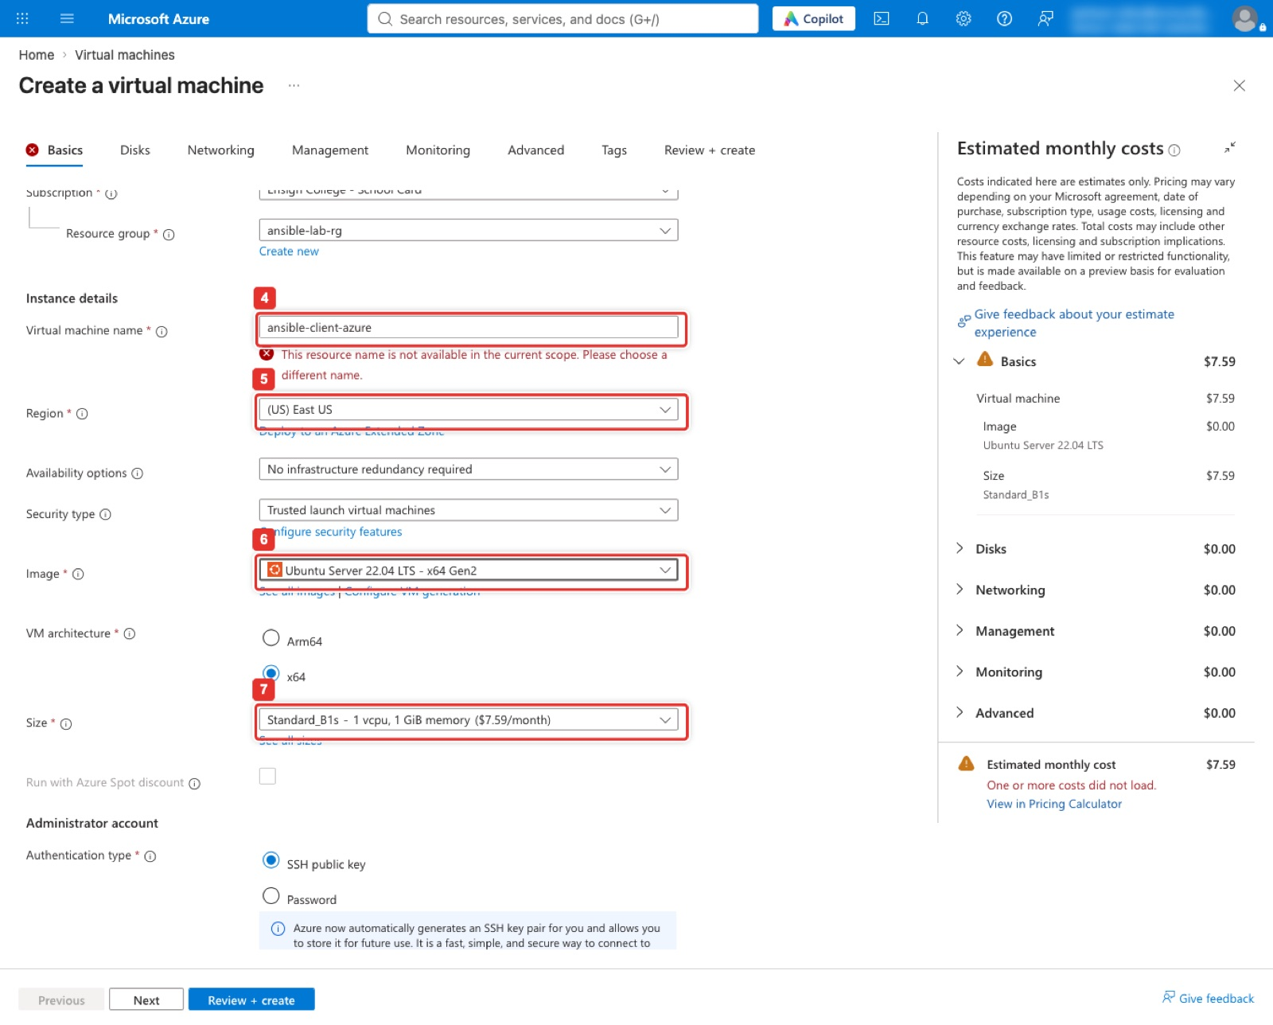
Figure 30. Instance details: name, region East US, image Ubuntu Server 22.04 LTS, size Standard_B1s.
What you see: The filled Instance details section. Virtual machine name (4) is ansible-client-azure; the red This resource name is not available message is there only because the instructor's VM of that name already exists, and you will not see it. Region (5) is (US) East US, Availability options is set to No infrastructure redundancy required so that small sizes are allowed, the Image (6) reads Ubuntu Server 22.04 LTS - x64 Gen2 after the marketplace steps, and the Size field, marked 7 in this figure only (in the Console box and the next figure 7 is the See all images link; Size is set with marks 11 to 13), reads Standard_B1s, 1 vcpu, 1 GiB at about $7.59 a month. The Estimated monthly costs panel on the right follows the size.
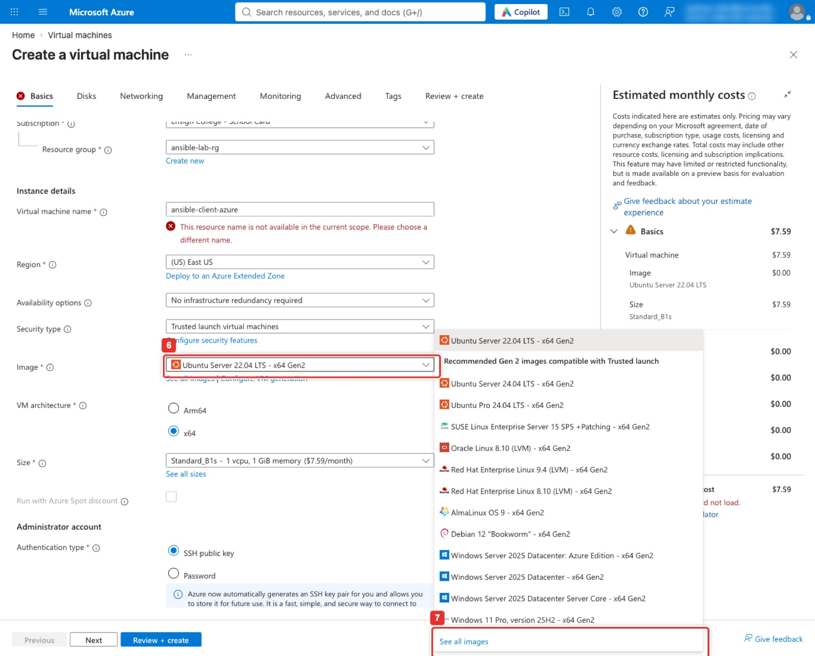
Figure 31. Image dropdown: no 22.04 in the quick list, so click See all images.
What you see: The Image dropdown (6) open. The quick list offers only Gen 2 images recommended for Trusted launch, and the newest Ubuntu in it is 24.04; the Ubuntu Server 22.04 entry at the very top appears only because the instructor had already chosen it through the Marketplace. See all images (7) at the bottom of the list opens the Marketplace in the next figure. If your instructor says 24.04 is acceptable, you can pick it here and skip the next two figures; every command in this lab works on both releases.
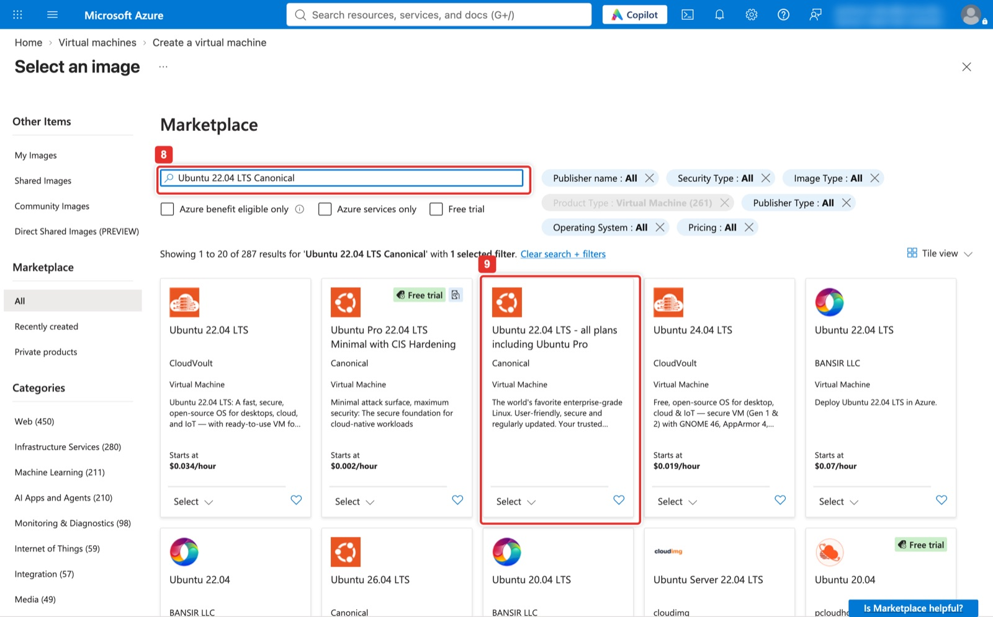
Figure 32. Select an image: search Ubuntu 22.04 LTS Canonical and find the Canonical all-plans card.
What you see: The Marketplace blade. The search box (8) holds Ubuntu 22.04 LTS Canonical; the results are tiles from many publishers, most of them paid third-party builds. The one you want is the Ubuntu 22.04 LTS - all plans including Ubuntu Pro card published by Canonical (9), with no hourly price on it. Its Select button at the bottom of the tile is a menu of plans.
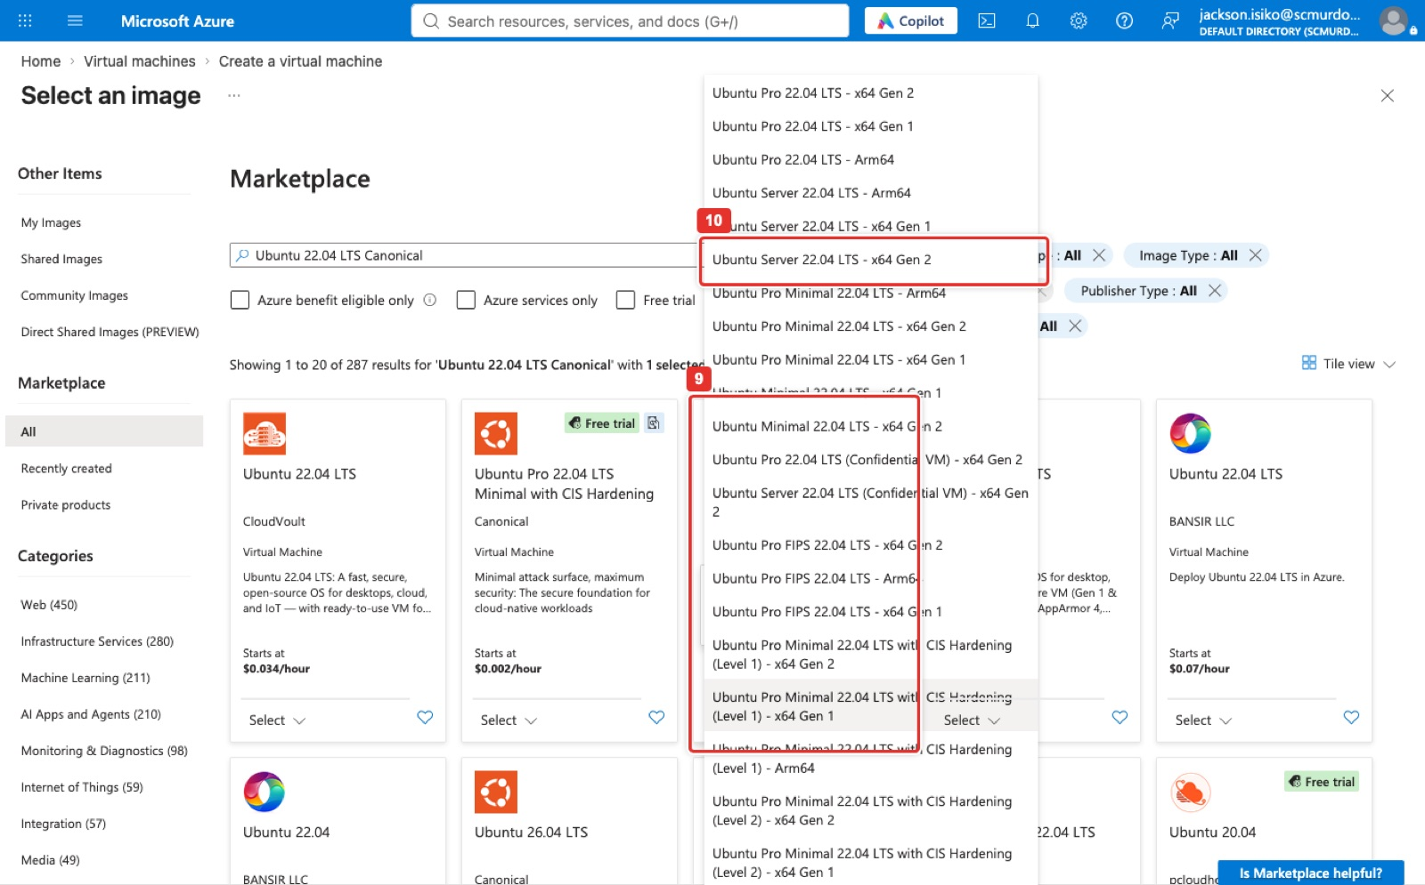
Figure 33. The Canonical card's Select menu: Ubuntu Server 22.04 LTS - x64 Gen 2.
What you see: The plan menu that opens from the Canonical card's Select button (9). The list mixes Ubuntu Pro (paid support), Minimal and Confidential VM plans; choose Ubuntu Server 22.04 LTS - x64 Gen 2 (10), which is the free standard server image and matches the Ubuntu2204 alias the CLI uses. The portal returns to the Basics tab with the Image field filled in.
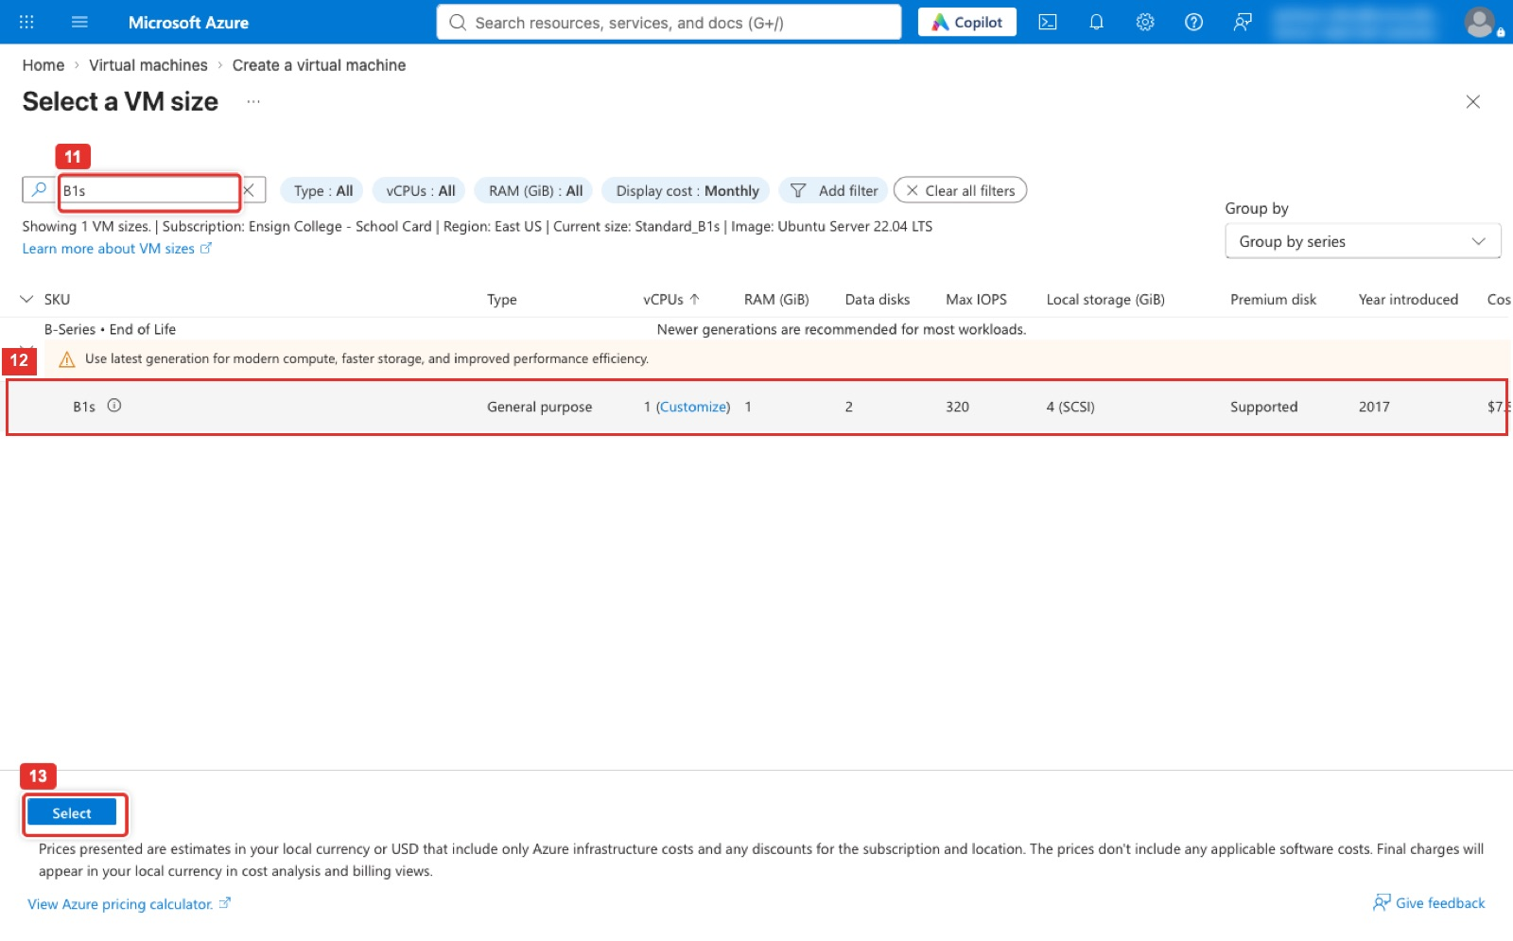
Figure 34. Select a VM size: search B1s, expand the B-Series group, tick B1s, Select.
What you see: The Select a VM size blade. Type B1s in the search box (11); the single match is grouped under B-Series, End of Life, which only means Azure recommends newer families and is harmless here. Click the B1s row (12), 1 vCPU, 1 GiB, about $7.59 a month, then Select (13). If the row is greyed out with a Sizes are not supported in zone 1 note, go back and set Availability options to No infrastructure redundancy required first.
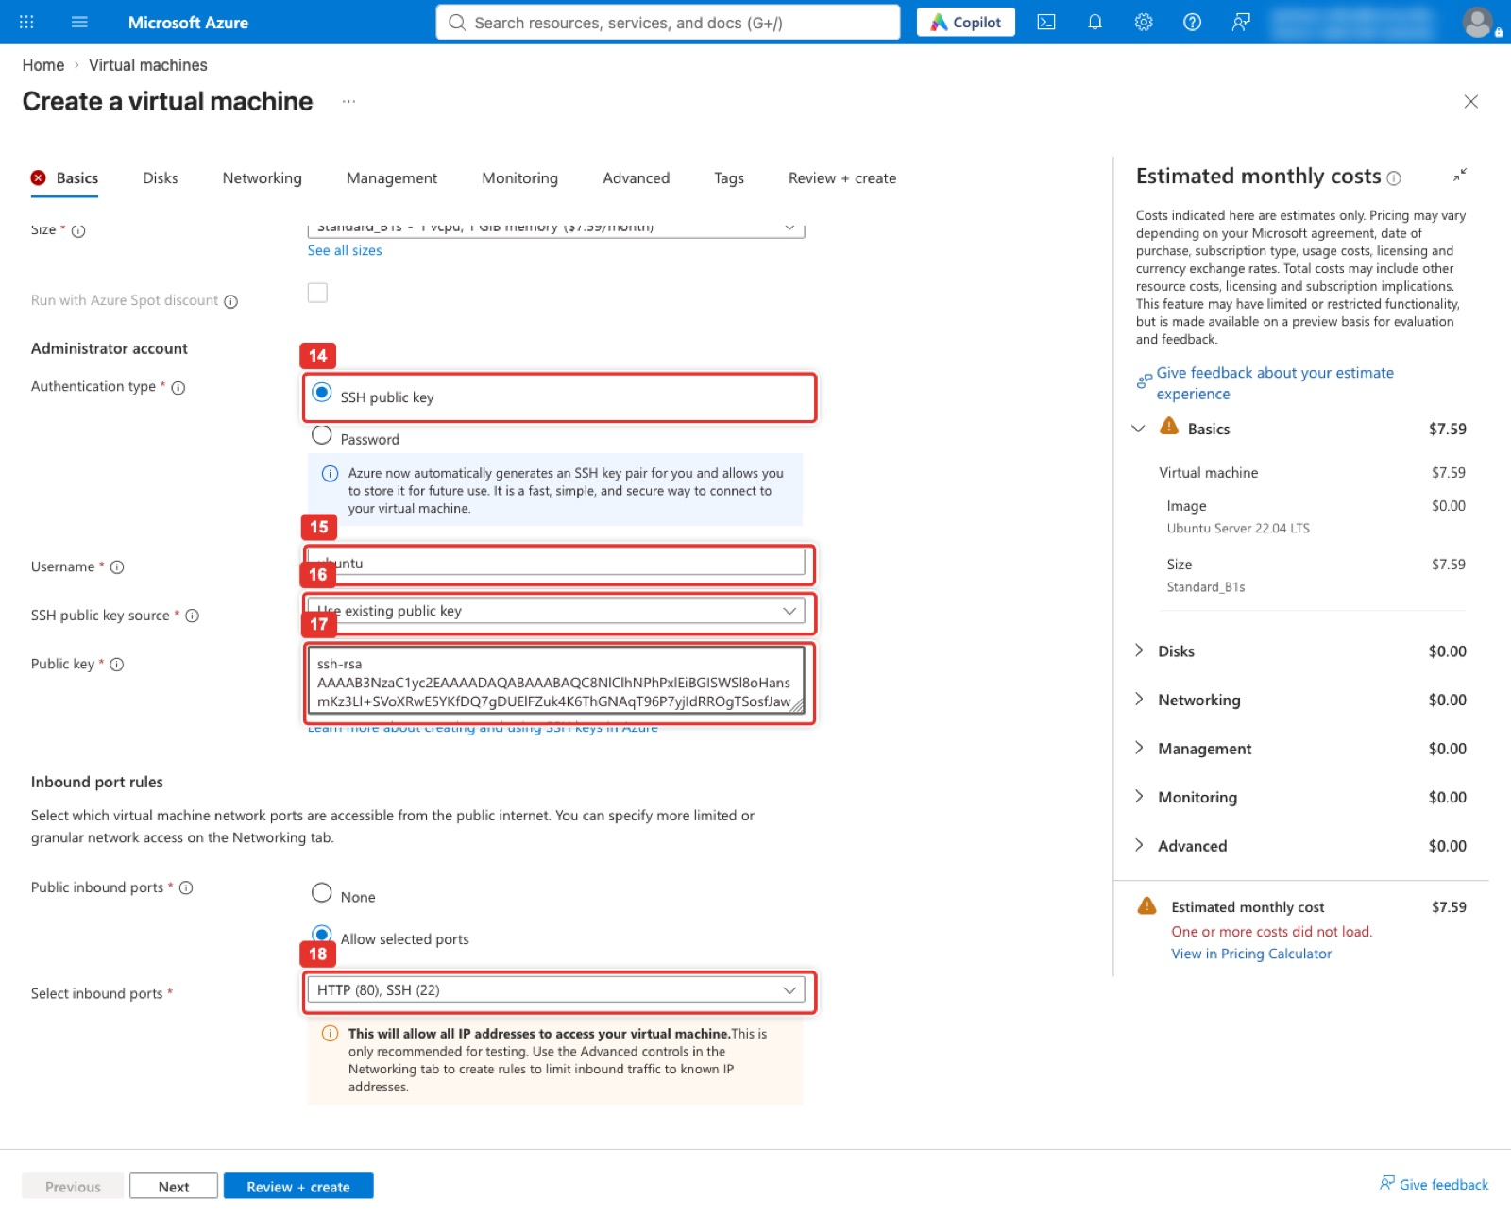
Figure 35. Administrator account and inbound ports: SSH public key, ubuntu, Use existing public key, paste, SSH and HTTP.
What you see: The lower half of the Basics tab. Authentication type is SSH public key (14). Username (15) is ubuntu, which must match ansible_user in the inventory. SSH public key source (16) is Use existing public key, which replaces the Generate new key pair option with a Public key box (17) where the controller's ssh-rsa line goes. Under Inbound port rules, Select inbound ports (18) shows SSH (22) and HTTP (80). The Networking tab is left at its defaults.
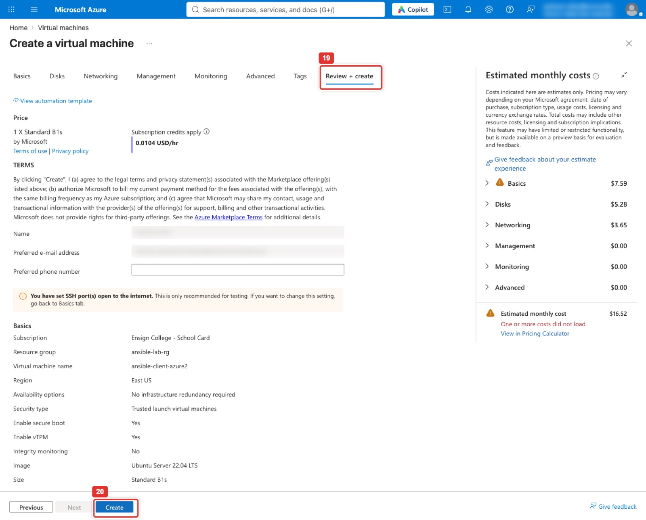
Figure 36. Review + create: Validation passed, then Create.
What you see: The Review + create tab (19) after validation passed: the Create button is enabled and no red banner is shown. The Price block states the hourly rate for one Standard B1s, the terms follow, and the Basics summary repeats the subscription, resource group, name, region, image and size. The name reads ansible-client-azure2 only because the instructor's VM already held the plain name; yours is ansible-client-azure. The yellow note that SSH is open to the internet is expected here and is tightened in the next figure but one. Create (20) at the bottom starts the deployment. If validation fails, the tab with the problem gets a red dot; the usual cause is a size that is not available in the region.
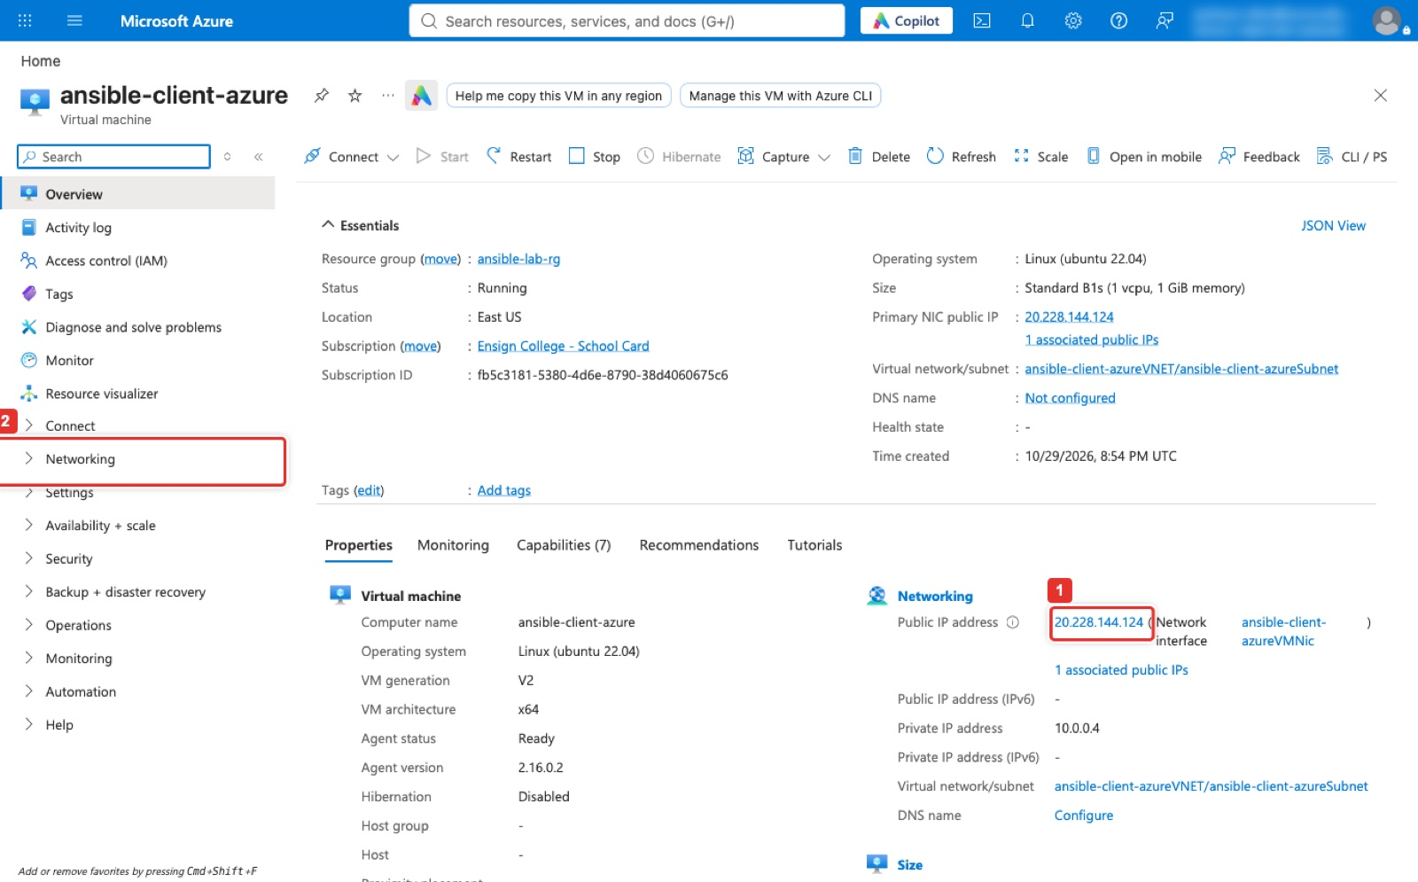
Figure 37. The VM's Overview page with its public IP address.
What you see: The Overview page of ansible-client-azure after deployment. The Essentials panel shows Status Running, Location East US, Size Standard_B1s, the operating system, and the Public IP address (1), which is AZURE_IP for the inventory. The Networking entry (2) in the left menu opens Network settings, shown in the next figure. Reset password, under Help, is where a lost key is replaced.
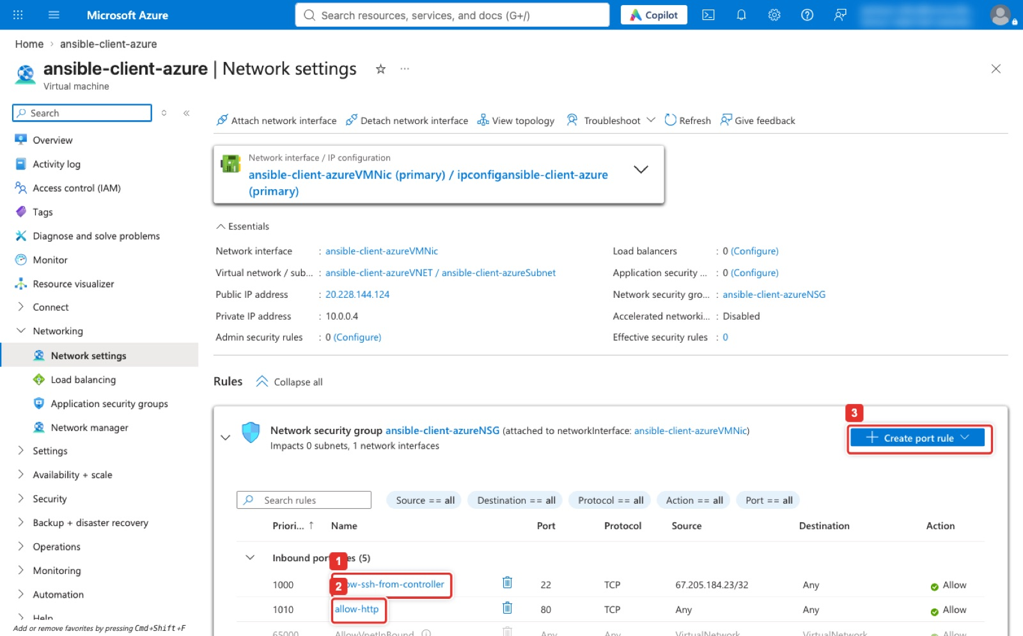
Figure 38. Networking → Network settings: inbound rules for ports 22 and 80.
What you see: The Network settings page of the VM, showing the rules of the network security group attached to its NIC. allow-ssh-from-controller (1) allows TCP 22 with Source set to the controller's IP only, which is the hardened version the Terminal path creates; the portal's Basics tab creates an equivalent rule open to Any instead. allow-http (2) allows TCP 80 from anywhere. If a port is missing, Create port rule (3) → Inbound port rule adds it here.
Terminal on your laptop with the Azure CLI signed in (same result, SSH restricted to the controller)
CIP=67.205.184.23
az group create -n ansible-lab-rg -l eastus
az vm create -g ansible-lab-rg -n ansible-client-azure -l eastus --image Ubuntu2204 \
--size Standard_B1s --admin-username ubuntu --ssh-key-values controller_id_rsa.pub \
--public-ip-sku Standard --nsg-rule NONE -o table
az network nsg rule create -g ansible-lab-rg --nsg-name ansible-client-azureNSG -n allow-ssh-from-controller \
--priority 1000 --protocol Tcp --source-address-prefixes $CIP/32 --destination-port-ranges 22 --access Allow
az network nsg rule create -g ansible-lab-rg --nsg-name ansible-client-azureNSG -n allow-http \
--priority 1010 --protocol Tcp --destination-port-ranges 80 --access Allow
az vm show -d -g ansible-lab-rg -n ansible-client-azure --query publicIps -o tsv

Expected result
Both VMs show a public IP and both have 22 and 80 open. That is Checkpoint 2. Write GCP_IP and AZURE_IP in the table on page 2.

Part C. Passwordless SSH from the controller (10 min)

Step 6. Prove the fleet key works on both clients
Back on the controller. BatchMode=yes makes ssh fail instead of asking for a password, so if a hostname prints, the key did all the work. The first connection to each client stores its host key; answer yes if asked.
On the controller
ssh -o BatchMode=yes -i ~/.ssh/id_rsa ubuntu@34.172.96.75 hostname
ssh -o BatchMode=yes -i ~/.ssh/id_rsa ubuntu@20.228.144.124 hostname

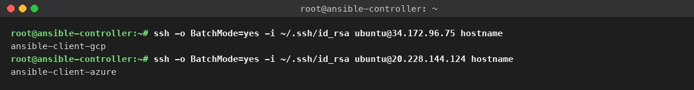
Figure 39. Both clients answer with their hostname and no password prompt.
What you see: Two ssh commands, one per client, each printing the remote hostname: ansible-client-gcp for the Google Cloud IP and ansible-client-azure for the Azure IP. Nothing else is printed, which is the point: no password, no warning. If a line says Permission denied (publickey), the key is not installed for user ubuntu on that VM; redo the SSH key part of Step 4 or 5 (on Azure: Reset password → Reset SSH public key). If it says Connection timed out, port 22 is closed to the controller.
Expected result
Both hostnames print with no prompt. That is Checkpoint 3.

Part D. Inventory, ping and the NGINX playbook (30 min)

Step 7. Write the inventory
The inventory is a text file that groups the hosts by cloud and tells Ansible which user and key to use. Make a working folder on the controller first so the files stay together.
On the controller
mkdir -p ~/lab2 && cd ~/lab2
cat > inventory.ini <<'EOF'
[azure]
20.228.144.124 ansible_user=ubuntu

[gcp]
34.172.96.75 ansible_user=ubuntu

[all:vars]
ansible_ssh_private_key_file=~/.ssh/id_rsa
ansible_ssh_common_args=-o StrictHostKeyChecking=accept-new
EOF
cat inventory.ini

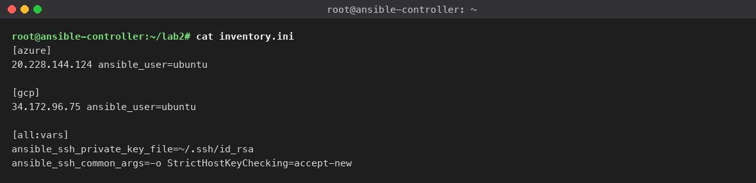
Figure 40. inventory.ini: one group per cloud, the fleet key and host-key handling for everyone.
What you see: The inventory printed back by cat. Each [group] header names a cloud and the line under it is that client's public IP with ansible_user=ubuntu. [all:vars] applies to every host: the private key path, and accept-new so Ansible stores each VM's host key on first contact instead of stopping to ask. Replace both IPs with yours; nothing else needs to change.

Step 8. Write the playbook
On the controller
cat > nginx.yml <<'EOF'
---
- name: Install and start NGINX
hosts: all
become: yes
tasks:
- name: Update APT
apt:
update_cache: yes

- name: Install NGINX
apt:
name: nginx
state: present

- name: Ensure NGINX is running
service:
name: nginx
state: started
enabled: yes
EOF
cat nginx.yml

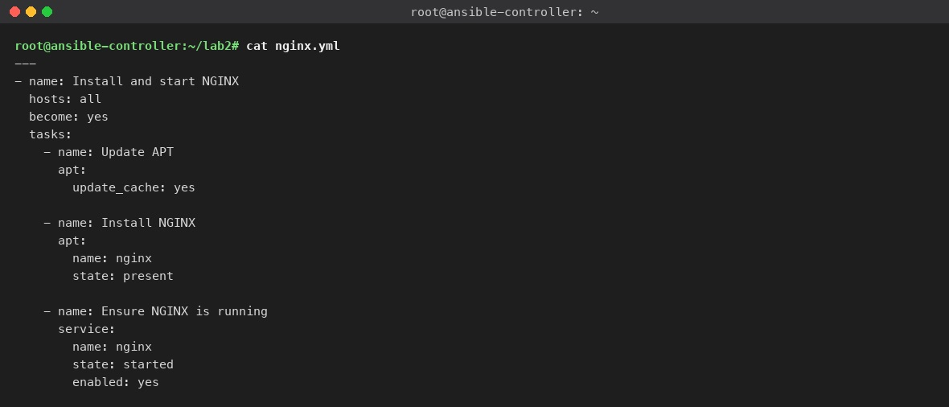
Figure 41. nginx.yml: one play, every host, three tasks.
What you see: The playbook printed back. hosts: all targets every host in the inventory, become: yes runs the tasks with sudo, and the three tasks refresh the package index, install the nginx package, and make sure the service is started and enabled at boot. Indentation is two spaces and matters: copy the file from ansible/nginx.yml in the lab folder if the heredoc goes wrong.

Step 9. Ping every host
On the controller
ansible all -i inventory.ini -m ping

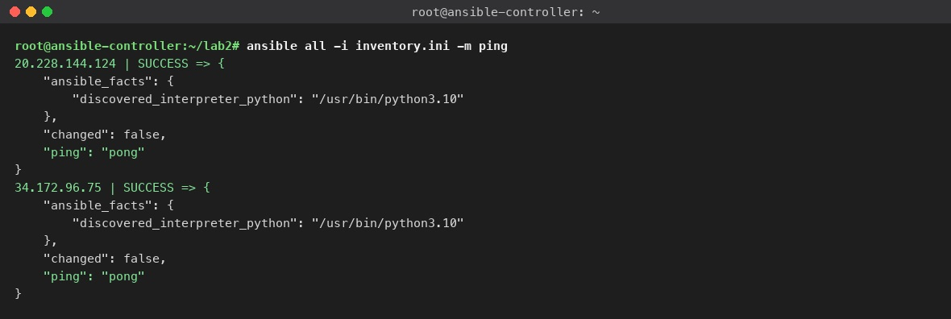
Figure 42. ansible ping: pong from the Azure and the GCP client.
What you see: The ping module logs in to each host over SSH, runs a tiny Python program and reports. Each host prints SUCCESS with "ping": "pong"; the discovered_interpreter_python fact shows Ansible found Python 3.10 on Ubuntu 22.04 by itself. The order of the two hosts changes from run to run. An UNREACHABLE line means the key or the port is wrong for that host, so go back to Step 6 for it.
Expected result
Every host answers pong. That is Checkpoint 4.

Step 10. Run the playbook and open both pages
On the controller
ansible-playbook -i inventory.ini nginx.yml
curl -s http://20.228.144.124 | grep -o '<title>.*</title>'
curl -s http://34.172.96.75 | grep -o '<title>.*</title>'

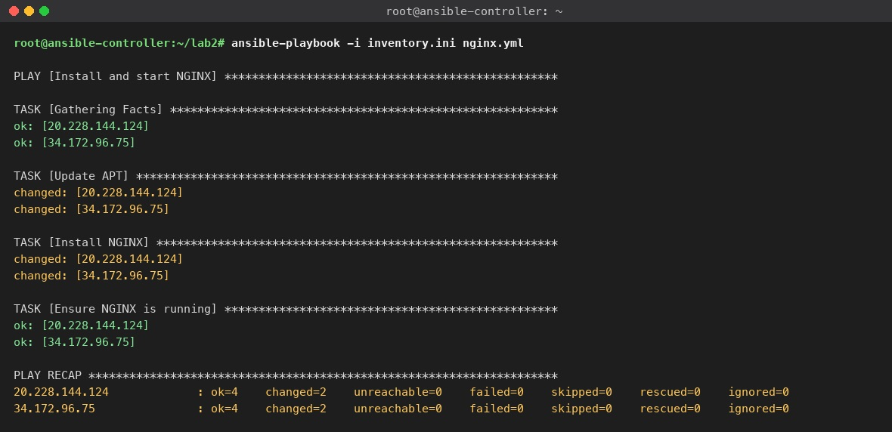
Figure 43. First run: every task, then the PLAY RECAP with changed=2 on both hosts.
What you see: The playbook output. Ansible first gathers facts, then prints each task with one line per host: ok in green means the state was already right, changed in yellow means Ansible did something. On a fresh VM Update APT and Install NGINX are changed and Ensure NGINX is running is ok, because the apt package starts the service itself. The PLAY RECAP at the end is what you screenshot for Canvas: ok=4 changed=2 unreachable=0 failed=0 on both hosts.
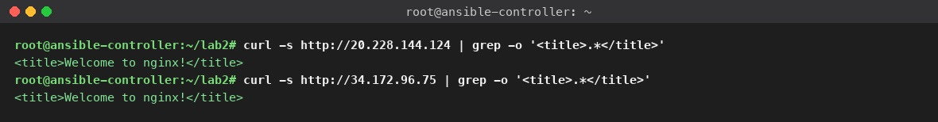
Figure 44. curl from the controller: the NGINX welcome title from both clients.
What you see: Two curl commands, one per public IP, each filtered to the HTML title. Both print Welcome to nginx!, which proves port 80 is open from the internet and the service is answering. Open the same two addresses in your browser and take one screenshot with both tabs visible for the Canvas deliverable (next figure).
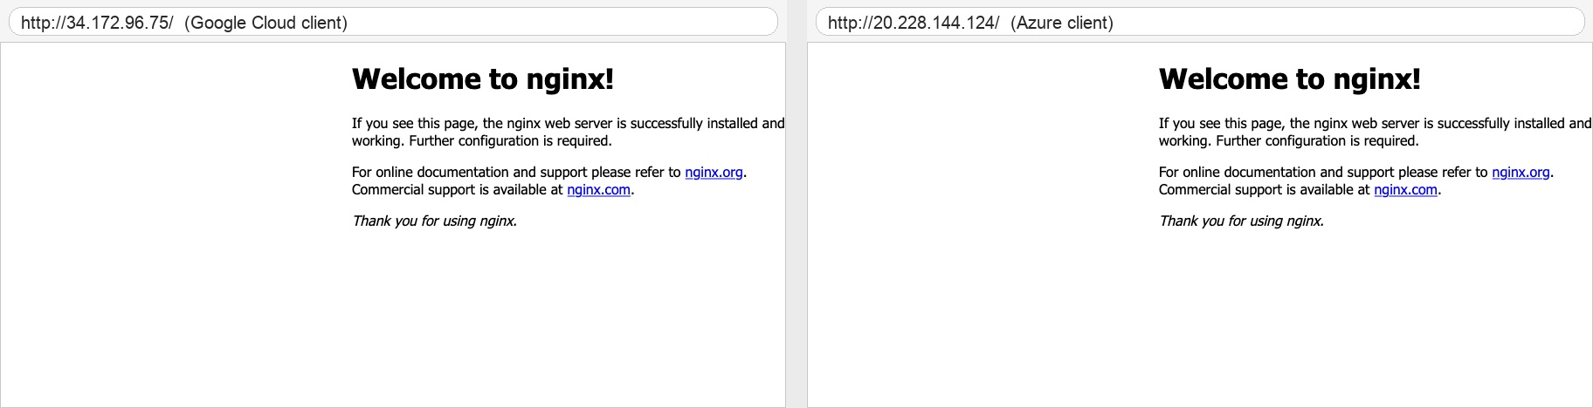
Figure 45. Both client IPs in a browser: Welcome to nginx! from Google Cloud and from Azure.
What you see: The default NGINX page served by each client, opened by its public IP in a browser; the address of each page is written above its capture, Google Cloud on the left and Azure on the right. The page is identical on both clouds because the same playbook produced it; only the address differs. Your own screenshot should show the two browser tabs with the addresses visible, which is the side-by-side deliverable Canvas asks for.
Expected result
Both pages show Welcome to nginx!. That is Checkpoint 5.

Step 11. Run it again: idempotency
Run the same playbook a second time and read the recap. Then run the version with cache_valid_time: 3600 on the apt task and read it again. One precision note from the 2026-10-31 verification run: cache_valid_time means the apt cache is trusted for an hour, so the idempotent playbook prints changed=0 when it runs within an hour of the previous run; after a longer pause its first run still refreshes the cache once (changed=1 on Update APT) and the run after that is changed=0.
On the controller
ansible-playbook -i inventory.ini nginx.yml # changed=1: only Update APT
sed 's/update_cache: yes/update_cache: yes\n cache_valid_time: 3600/' nginx.yml > nginx-idempotent.yml
ansible-playbook -i inventory.ini nginx-idempotent.yml # changed=0

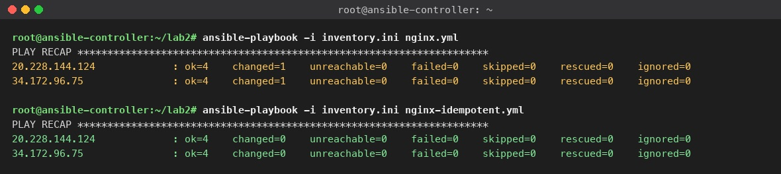
Figure 46. Second run changed=1 (the apt cache refresh), idempotent playbook changed=0.
What you see: Two recaps. The plain nginx.yml run a second time reports changed=1 on each host: NGINX is already installed and running, so only Update APT reports a change, because refreshing the package index counts as one. nginx-idempotent.yml tells the apt module that a cache younger than an hour is good enough, and its recap reads changed=0 on both hosts. That recap is the second screenshot Canvas asks for. Idempotent means the playbook describes an end state and does nothing when the state is already correct.

Part E. Verify the Ansible deployment (10 min)
The recap says what Ansible did. These commands, all run on the controller, let you prove the result from the outside and are the ones to reach for when something does not work. Each uses the same inventory, so they also confirm the inventory itself.
Check | Command on the controller | Expected
Inventory parses and groups are right | ansible-inventory -i inventory.ini --graph | @azure and @gcp each with one IP
Every host reachable with the key | ansible all -i inventory.ini -m ping | SUCCESS ... "ping": "pong" per host
NGINX service is active | ansible all -i inventory.ini -m command -a "systemctl is-active nginx" | active per host
Port 80 is listening on the VM | ansible all -i inventory.ini -m shell -a "ss -ltn | grep :80" | LISTEN ... :80 lines
Package version installed | ansible all -i inventory.ini -m command -a "nginx -v" | nginx version: nginx/1.18.0 (Ubuntu)
Page answers locally on the VM | ansible all -i inventory.ini -m uri -a "url=http://localhost/" | "status": 200
Nothing left to change (dry run) | ansible-playbook -i inventory.ini nginx-idempotent.yml --check | changed=0 on every host
Right OS on the targets | ansible all -i inventory.ini -m setup -a "filter=ansible_distribution*" | Ubuntu 22.04 jammy
Playbook syntax | ansible-playbook -i inventory.ini nginx.yml --syntax-check | playbook: nginx.yml and nothing else
Playbook plan, no connection | ansible-playbook -i inventory.ini nginx.yml --list-hosts --list-tasks | hosts (2) with both IPs, then the three task names
Page answers from the internet | curl -s -o /dev/null -w '%{http_code}' http://<IP>/ | 200

On the controller (ad-hoc commands: one module, every host)
ansible-inventory -i inventory.ini --graph
ansible all -i inventory.ini -m command -a "systemctl is-active nginx"
ansible all -i inventory.ini -m shell -a "ss -ltn | grep :80"
ansible all -i inventory.ini -m command -a "nginx -v"
ansible all -i inventory.ini -m uri -a "url=http://localhost/ return_content=no" | grep -E "SUCCESS|status"

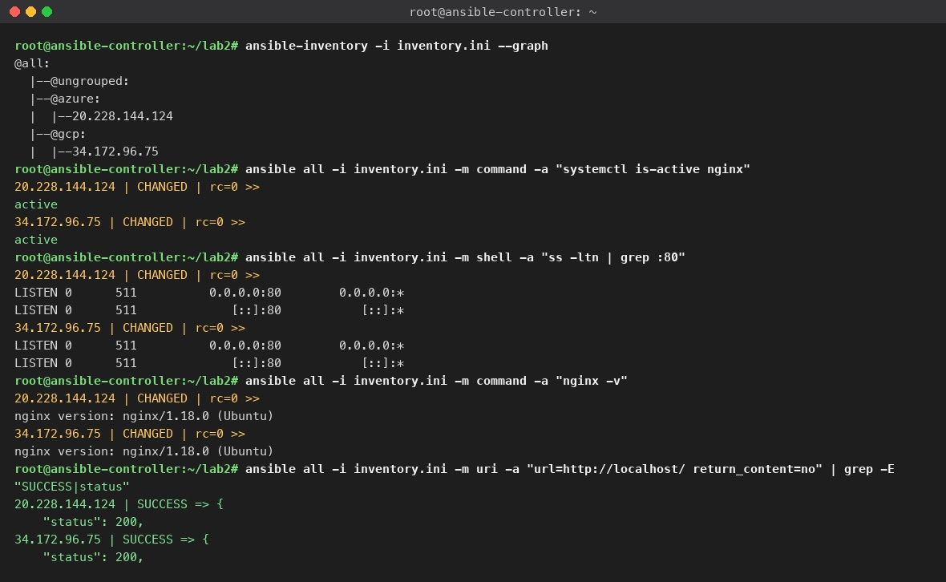
Figure 47. Ad-hoc verification: inventory graph, service state, listening port, version, local HTTP status.
What you see: Five ad-hoc commands and their output. ansible-inventory --graph draws the groups: @azure and @gcp with one address each under @all. The command and shell modules run one Linux command on every host and print its output under the host's IP: active from systemctl, two LISTEN lines for port 80 (IPv4 and IPv6), and the nginx version. The uri module fetches the page from inside the VM and reports "status": 200. CHANGED on a command module only means a command ran; it is not an error.
On the controller (dry run and facts)
ansible-playbook -i inventory.ini nginx-idempotent.yml --check
ansible all -i inventory.ini -m setup -a "filter=ansible_distribution*"

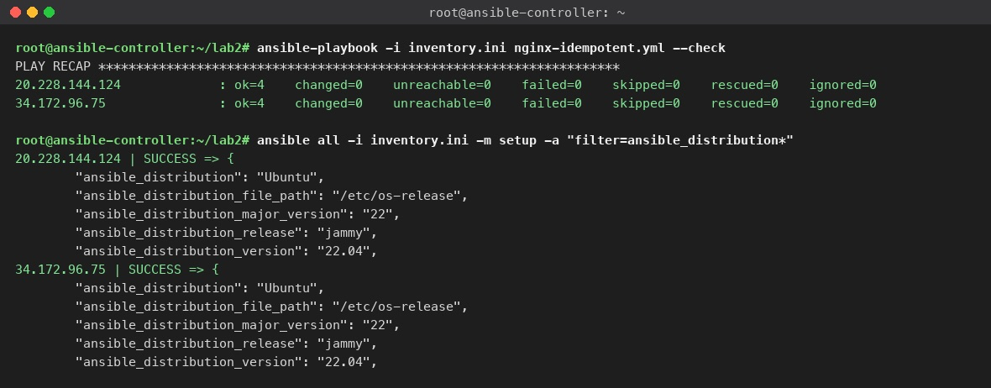
Figure 48. Dry run with --check (changed=0) and the distribution facts of both targets.
What you see: --check runs the playbook without changing anything and reports what it would change; changed=0 on both hosts means the fleet already matches the playbook. The setup module with a filter prints a few facts per host: distribution Ubuntu, release jammy, version 22.04, which confirms both clients run the image you chose in Part B. Facts like these are what you would use later to make a playbook behave differently per OS.
On the controller (syntax and plan, no connection needed)
ansible-playbook -i inventory.ini nginx.yml --syntax-check
ansible-playbook -i inventory.ini nginx.yml --list-hosts --list-tasks

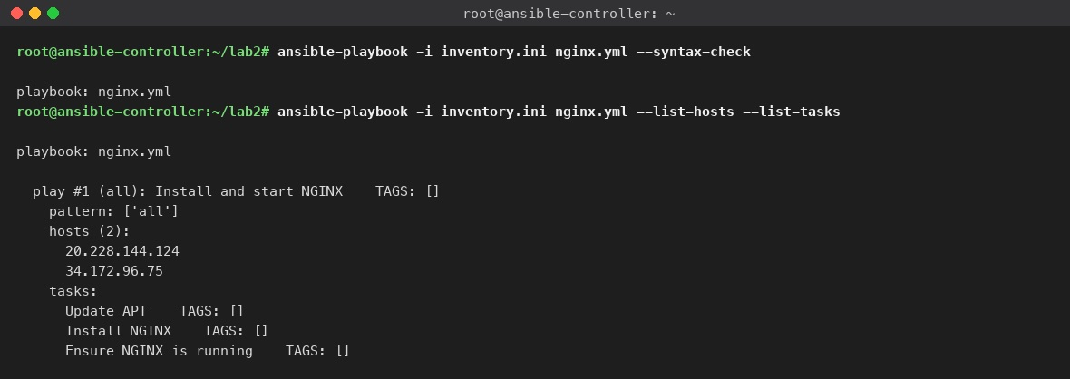
Figure 49. Syntax check and the list of hosts and tasks the playbook would run.
What you see: --syntax-check parses the YAML and prints only playbook: nginx.yml when it is valid; an indentation mistake prints the line number instead. --list-hosts --list-tasks shows the plan without running it: play #1 targets pattern all, which resolves to the two IPs, and the three task names in order. Run these two before every playbook change.
Note
From your laptop, bash scripts/verify-lab2.sh <PROJECT_ID> runs the cloud-side checks (the three VMs exist), the ping, the idempotent playbook and both curls in one go. It needs doctl, gcloud and az signed in.

Part F. Clean up (5 min)
Three clouds, three bills. Take your screenshots first (Part G), then delete in this order: the two clients, then the controller.

Google Cloud
Console: where to click
Compute Engine → VM instances: tick ansible-client-gcp (1) → More actions (2) → Delete (3), confirm. Delete the allow-ssh-ansible firewall rule only if you created it.

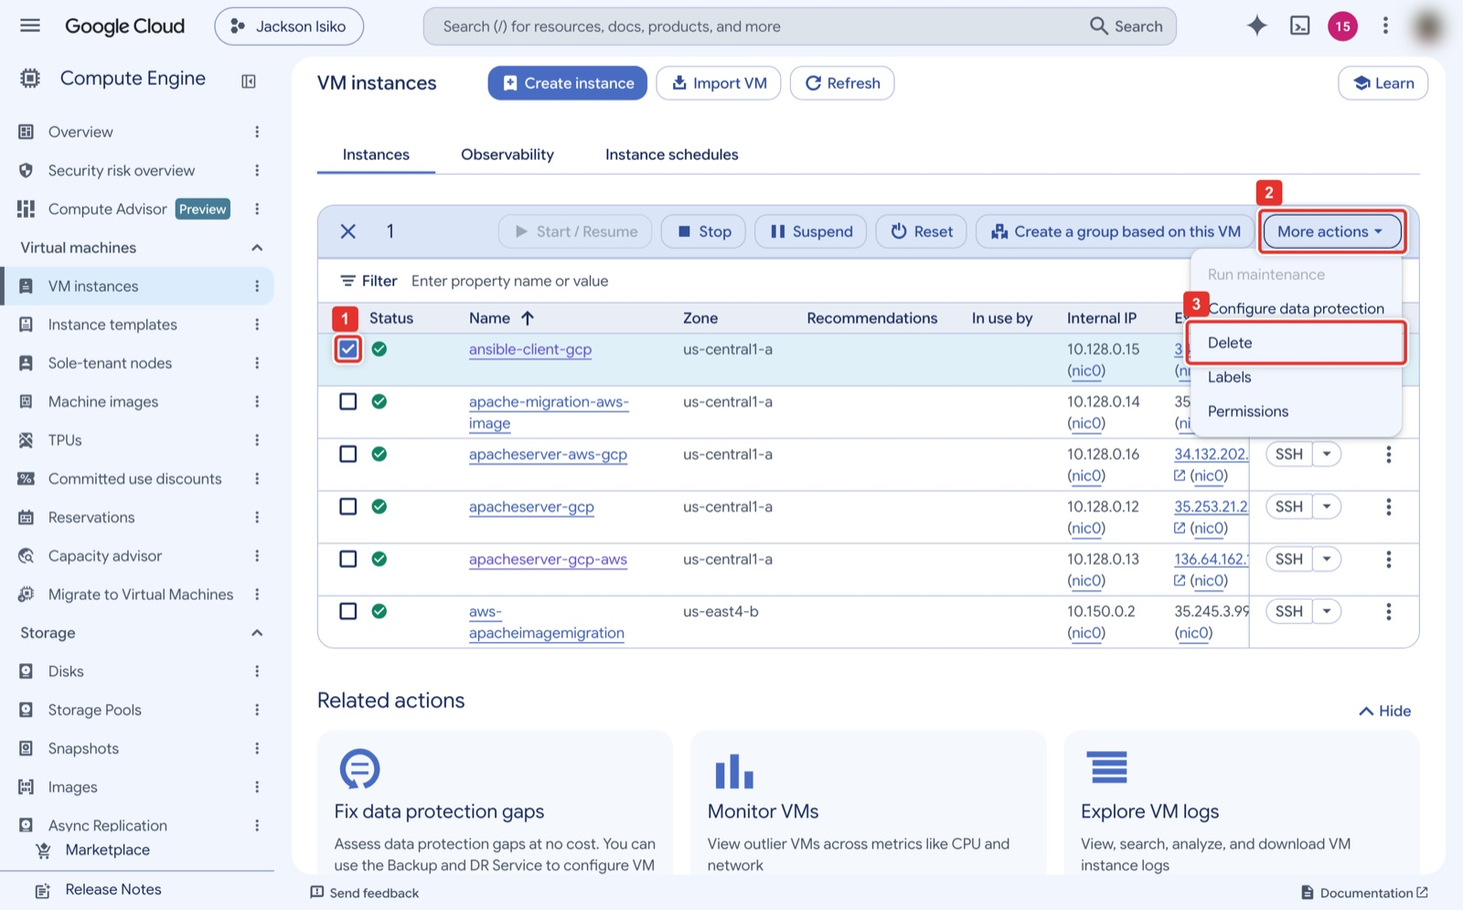
Figure 50. VM instances → tick the VM → More actions → Delete.
What you see: The VM instances list with ansible-client-gcp ticked (1). The toolbar changes to show Stop, Suspend, Reset and More actions (2); Delete (3) in that menu removes the VM and its boot disk after a confirmation dialog. Only tick your own VM; the other rows in the instructor's project are Lab 1 servers.

Azure
Console: where to click
Resource groups → ansible-lab-rg (the group lists six resources) → Delete resource group (1), type the group name to confirm (2), Delete (3). This removes the VM, disk, NIC, public IP, NSG and virtual network together. Vocareum: delete just the VM and its NIC, IP, NSG, VNet and disk, since the group is pre-created.

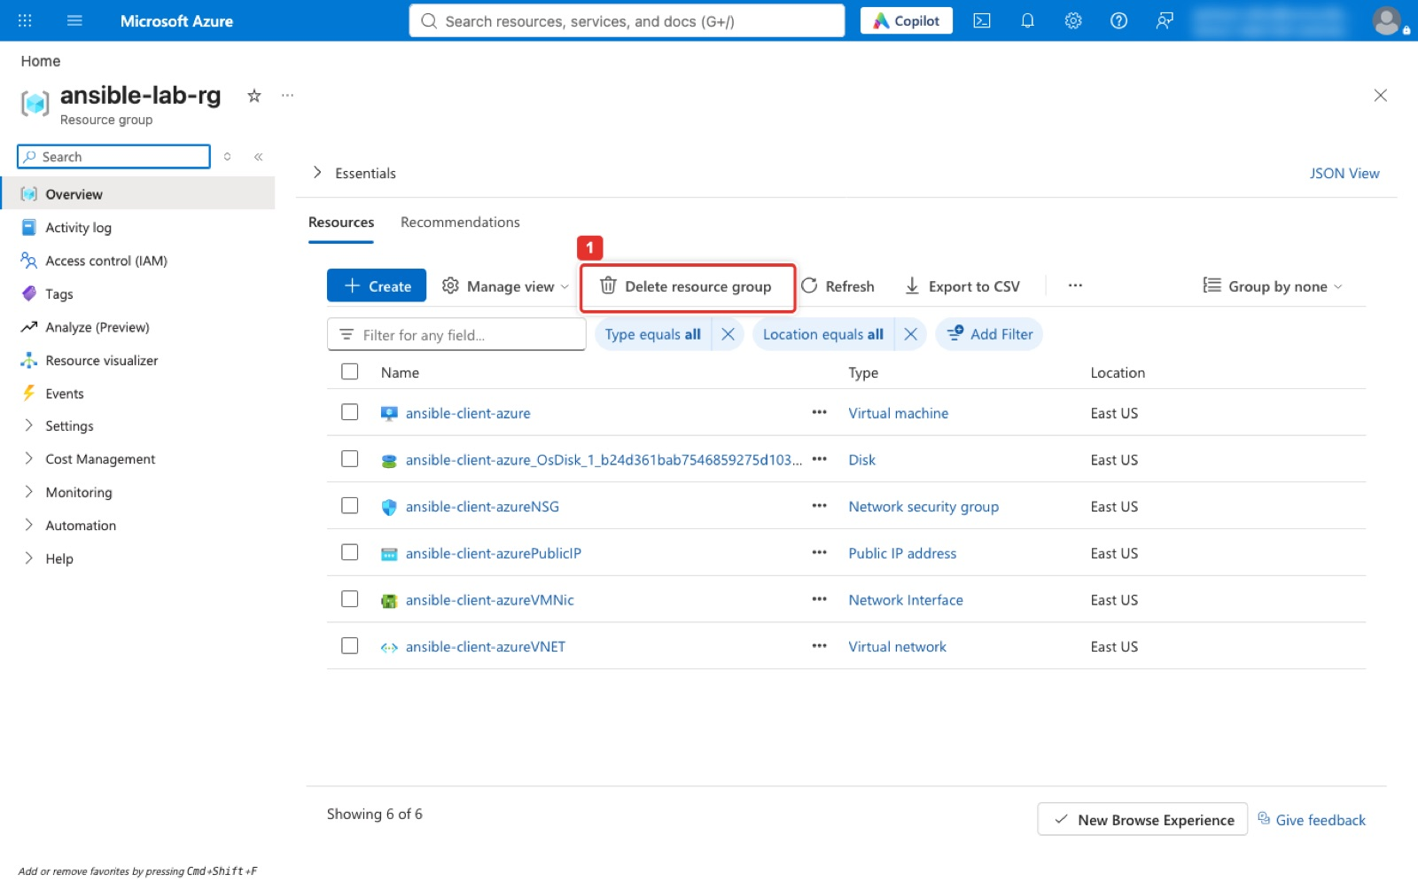
Figure 51. Resource groups → ansible-lab-rg: the six resources Lab 2 created, and Delete resource group.
What you see: The resource group page listing everything Lab 2 created in Azure: the virtual machine, its disk, network interface, public IP address, network security group and virtual network, six resources in all. Delete resource group (1) in the toolbar opens the side panel in the next figure. Deleting the group is the only way to be sure nothing is left behind; deleting the VM alone keeps the disk, the IP and the network, which still bill.
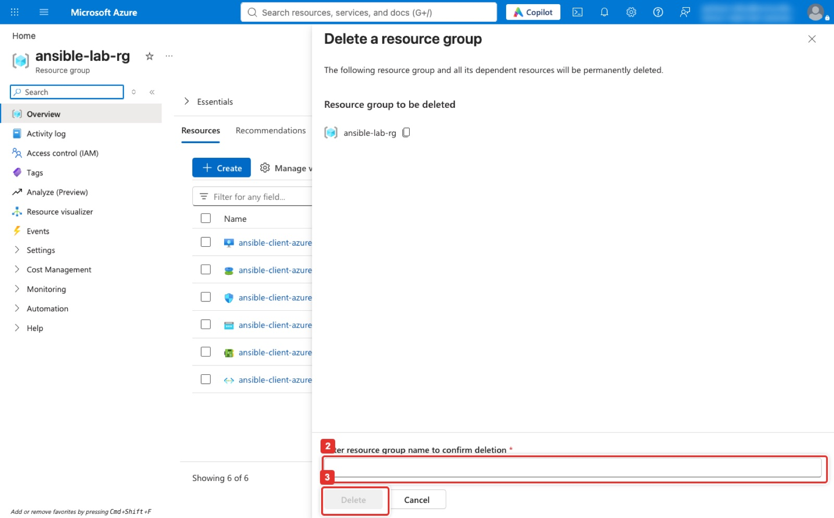
Figure 52. Delete a resource group: type the name to confirm, then Delete.
What you see: The Delete a resource group panel. It names the group to be removed and asks you to type that name into Enter resource group name to confirm deletion (2); the Delete button (3) stays greyed out until the name matches exactly. Deletion runs for a minute or two in the background and the group disappears from the Resource groups list when it is done.

DigitalOcean
Console: where to click
Droplets → ansible-controller → Settings tab (1) → scroll to the bottom → Destroy (2) and confirm. Destroying the controller also destroys the fleet private key, which is what you want.

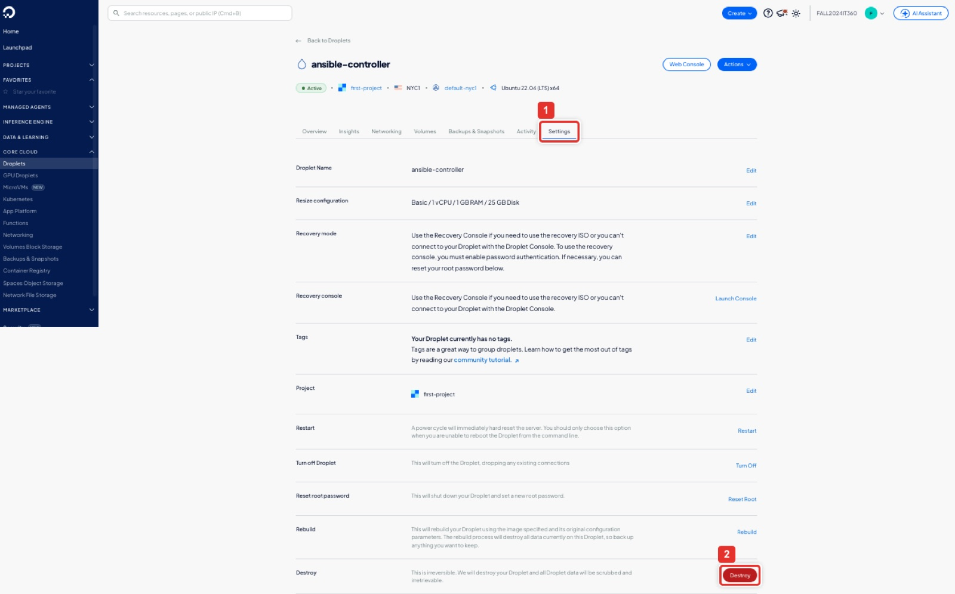
Figure 53. Droplet → Settings → Destroy.
What you see: The droplet's Settings tab (1), zoomed out so the whole page fits. Destroy is the last row, after Restart, Turn off, Reset root password and Rebuild; the red Destroy button (2) asks for a confirmation and then removes the droplet and its disk. Billing stops immediately; a powered-off droplet still bills, so destroy rather than turn off.

AWS (only if the controller was built in Step 1A)
Console: where to click
EC2 → Instances: tick ansible-controller (1), Instance state (2) → Terminate (delete) instance (3), confirm, and wait until the state reads Terminated. Then Security Groups: tick the group the launch wizard created (launch-wizard-N; ansible-controller-sg if you used the CloudShell block) → Actions → Delete security groups, and Key Pairs: tick ansible-controller-key → Actions → Delete. On Vocareum, end the lab session as well.

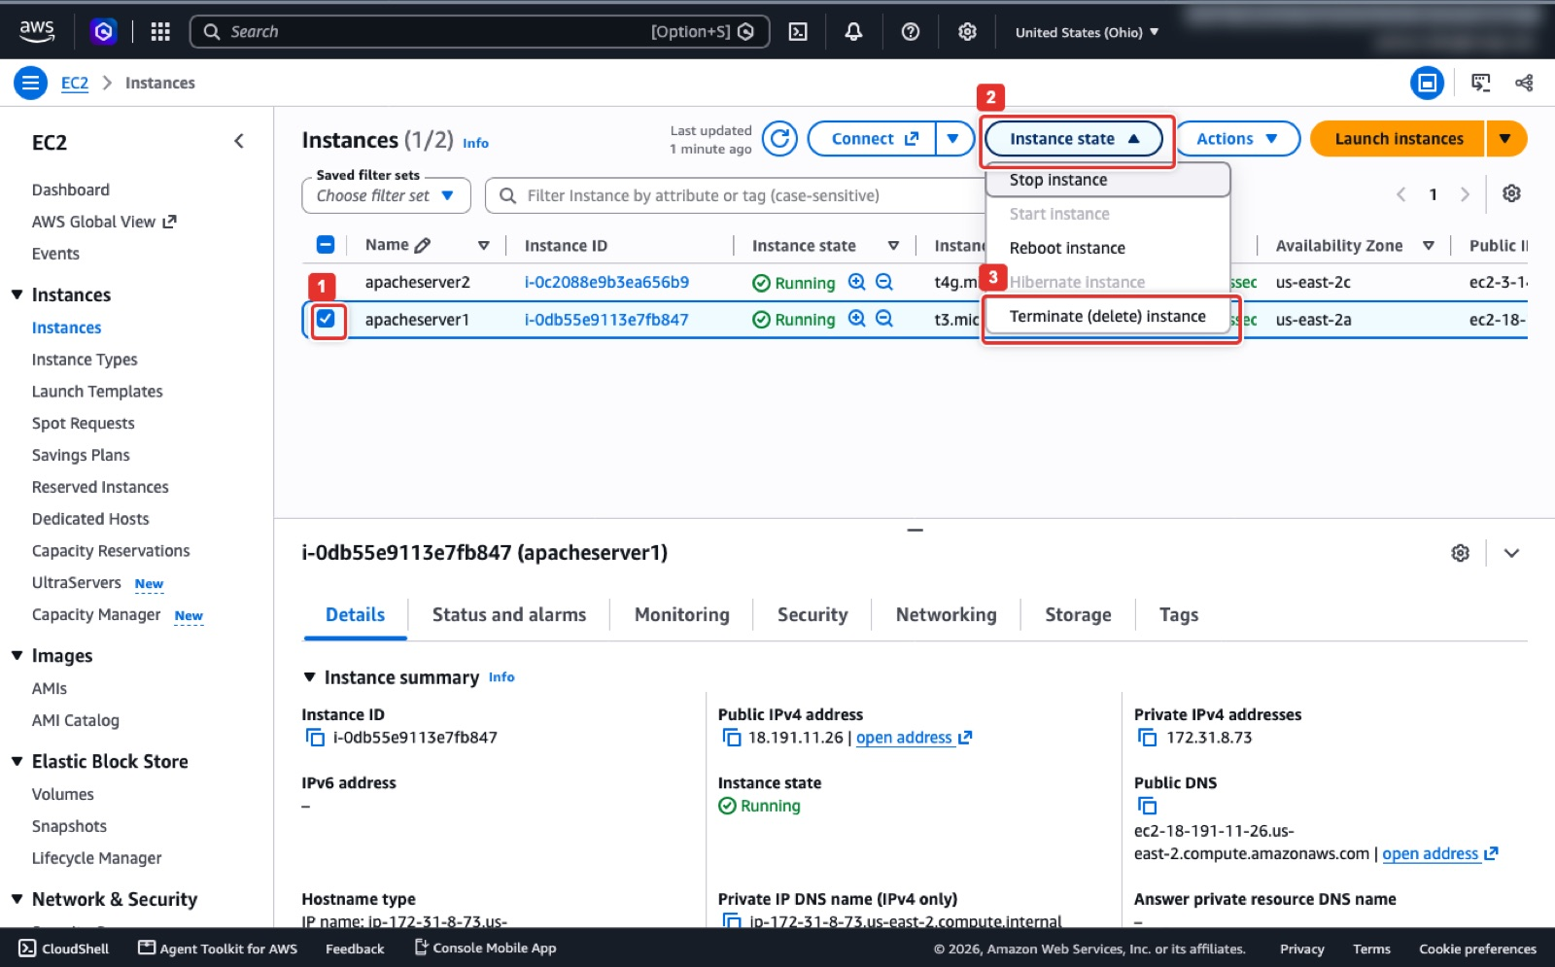
Figure 54. Instance state → Terminate (delete) instance.
What you see: EC2 → Instances with the instance ticked (1); the figure shows the Lab 1 server, yours reads ansible-controller. Instance state (2) opens a menu with Stop, Reboot and Hibernate; Terminate (delete) instance (3) at the bottom removes the VM and its root volume, and with it the fleet private key, after a confirmation dialog. Stop would keep billing the disk; Terminate is what the lab needs.
AWS CloudShell (same result)
aws ec2 terminate-instances --instance-ids <INSTANCE_ID>
aws ec2 wait instance-terminated --instance-ids <INSTANCE_ID>
aws ec2 delete-security-group --group-name ansible-controller-sg # CloudShell build; a console build: --group-name launch-wizard-N
aws ec2 delete-key-pair --key-name ansible-controller-key
aws ec2 describe-instances --filters Name=tag:Name,Values=ansible-controller Name=instance-state-name,Values=running --query 'Reservations[].Instances[].InstanceId' # expect []

Terminal on your laptop (same result; or `bash scripts/rollback-lab2.sh <PROJECT_ID> -y` for all three)
gcloud compute instances delete ansible-client-gcp --zone=us-central1-a --quiet
gcloud compute firewall-rules delete allow-ssh-ansible --quiet # only if you created it
az group delete -n ansible-lab-rg --yes
doctl compute droplet delete ansible-controller --force
# proof: all three empty
gcloud compute instances list --filter=name=ansible-client-gcp; az vm list -o table; doctl compute droplet list

Expected result
All three list commands print nothing from this lab (on an AWS controller, the EC2 query prints []). If you used the Vocareum labs, end them so the sandbox stops the clock.

Part G. What to submit (Canvas 1.6)
- inventory.ini and nginx.yml as files or pasted text.
- A screenshot of the PLAY RECAP of the first run (changed=2, Step 10) and of the idempotent run (changed=0, Step 11).
- One screenshot with both NGINX pages open side by side, the two public IPs visible in the address bars.
- The Team Collaboration and Documentation section: who held the controller, Azure, GCP and automation roles and what each contributed.

Appendix. Quick troubleshooting
Symptom | Cause | Fix
Permission denied (publickey) from the controller | Key not installed for user ubuntu on that VM, or GCP key comment not ubuntu | Re-add the controller's .pub through the console (Step 4 or 5); on Azure use Reset password → Reset SSH public key
ssh: connect to host ... port 22: Connection timed out | Port 22 closed to the controller | Azure: NSG inbound rule for 22. GCP: firewall rule tcp:22 to the VM's tag
Browser or curl times out on port 80 | Port 80 closed | Azure: NSG rule for 80. GCP: default-allow-http plus the http-server tag
UNREACHABLE in ping | Wrong IP, wrong user or key in the inventory | ansible-inventory --graph, then Step 6 by hand for that host
ansible: command not found right after install | Shell has not re-read PATH | hash -r or a new SSH session
Warning about the Python interpreter | Informational | Add interpreter_python = auto_silent to an ansible.cfg next to the inventory
Second run shows changed=1 | update_cache: yes counts the index refresh as a change | Expected; add cache_valid_time: 3600 (Step 11)
Azure: SkuNotAvailable for B1s | Capacity restriction for that region | Try Standard_B2s or Standard_D2s_v4, or another region
Azure: B1s greyed out in the size picker | Availability zone selected | Set Availability options to No infrastructure redundancy required
Azure CLI on the laptop refused (Vocareum) | Conditional Access blocks the CLI app | Use the portal's Cloud Shell
GCP: cannot create firewall rule (Vocareum) | Lab role lacks the permission | Use a personal project, or an existing default rule
DigitalOcean: droplet has no IP in doctl yet | --wait returns before the IP is assigned | List again after five seconds
DigitalOcean refuses the sign-up, or the new account is on hold | New-account verification, card refused, or no trial in your country | Use the GitHub Student Developer Pack credit, or build the controller on AWS (Step 1A) and carry on
AWS controller: Permission denied (publickey) as root | EC2 Ubuntu images log in as ubuntu, never root | ssh -i ~/.ssh/ansible-controller-key.pem ubuntu@<CONTROLLER_IP>
AWS controller: SSH times out | Security group SSH rule holds a different IP (CloudShell, other network) | EC2 → Security Groups → edit inbound rule → source My IP

Measured time on 2026-10-29: controller 4 minutes, both clients 6 minutes, SSH, inventory and playbooks 5 minutes, verification 3 minutes. The one-command script does Parts A to D in 8 minutes.

